**Java**

**Intro**

* Purely object oriented
* It is both a compiled and interpreted language. The source code is first compiled to byte code which is then interpreted to machine code.

Structure

Function🡪Classes🡪Package

Function: Code to run a specific task. For eg: A function which adds two numbers.

Class: A collection of similar functions. For eg: A class of mathematical operations.

Naming convention:

Functions: We use PascalConvention. Eg: IAmParantapMishra

Classes: We use camelCaseConvention. Eg: iAmParantapMishra

Variable is a container that contains some value and the value is know as literal.

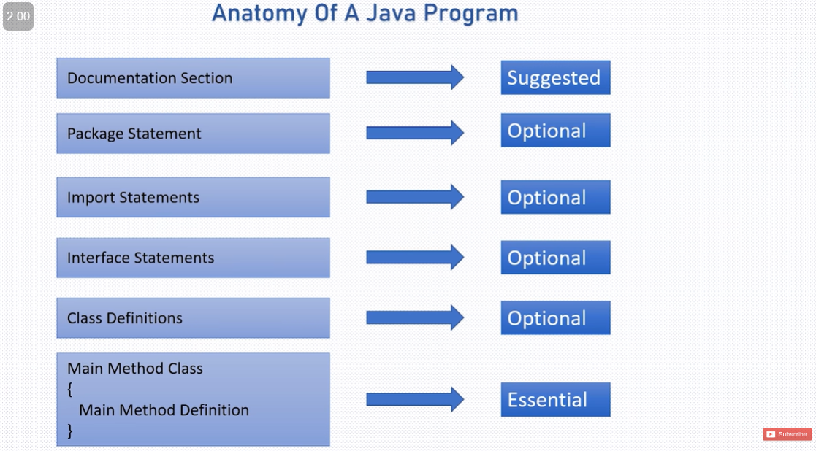

Rules for declaring variables:

* Must not begin with a number
* Cannot be a keyword
* Cannot contain whitespaces
* Name is case sensitive
* Can contain alphabets, digits, ‘$’ and ‘_’

println() prints in new line. print() will print in same line.

Data types:

Variables in java are statically typed. They need to be declared before using them.

Primitive Data types (Intensive):

1. byte: Stores one byte. Can store value from -128 to 127. Default value is 0.
2. short: stores 2 bytes. Can store value from -(216)/2 to (216)/2-1. Default value is 0.
3. int: Stores 4 bytes. –(232)/2 to (232)/2-1. Default value 0.
4. float: stores 4 bytes. default value 0.0f (f is written it denote it is a float and it is essential)
5. long: Stores 8 bytes. Default value 0. Need to use L in end.
6. double: Stores 8 bytes. Default value 0.0d (d is written to denote it is a double but it is optional). Double is the default type for any decimal value
7. char: Unsigned 16-bit integer with a range of 0 ('\u0000') to 65535 ('\uffff'). (Need to enclose value in single quotes.
8. Boolean: true or false. Default false.

You can add double/float to an integer.

String str=”Hello world”(can’t use single quotes)

For inputs see ‘Basics&Inputs’

Operators

7+11=18

7, 11: operands

+: operator

18: result

Types of operators:

1. Arithmetic operator: +,-,*,/,%,++, - -;
   1. ++/-- : increment or increase the value by one/ decrement.
2. Assignment operator: =, +=, *= etc. (a*=b is a=a*b)
3. Comparison operator: = = , >=, <=
4. Logical operators:
   1. &&: and operator. Returns true only when everything is true
   2. ||: or operator. Returns true even when one thing is true.
   3. !: not operator. Inverts Boolean operator. !(false)=true.

Arithmetic operators don’t work with booleans

**AP CSA**

It is both a compiled and interpreted language. The source code is first compiled to byte code which is then interpreted to machine code.

public class Main {

public static class Letter{

static void letter(){

opening();

closing();

}

static void opening(){

System.out.println("Greetings");

}

static void closing(){

System.out.println("Bye");

}

}

public static void main(String[] args) {

Letter.letter();

}

}

We don't get an error when opening() and closing() are called inside the letter() method—even though they are defined below it. **Why?:**

When the Java compiler parses the Letter class, it scans and registers all method signatures (names, return types, and parameters) before actually compiling their implementation. By the time the letter() method is being compiled, the signatures of opening() and closing() methods are already known to the compiler. This allows opening() and closing() to be called within letter() before their actual implementation is encountered. When letter() is compiled, it simply references the already-registered opening() and closing() methods. The actual position of the method in the source code doesn't matter to the compiler, as long as the method is defined somewhere in the class.

Therefore Java uses a single-pass compilation process and supports forward references within the same class.

# The first thing that the JVM searches and runs for program execution is the public static void main(String[] args).

**1.1**

/* blah blah */ is used for multiline comments. Remember it is backslash.

// is used for single line comments

Learn the initial two lines as well since in exam we wont get ide.

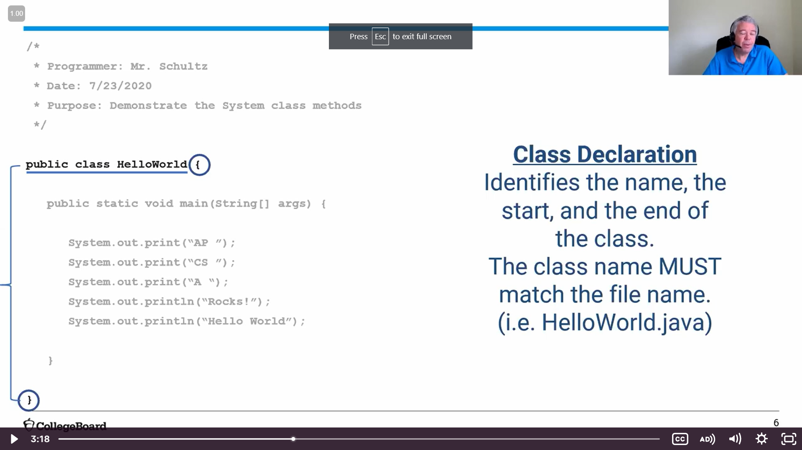

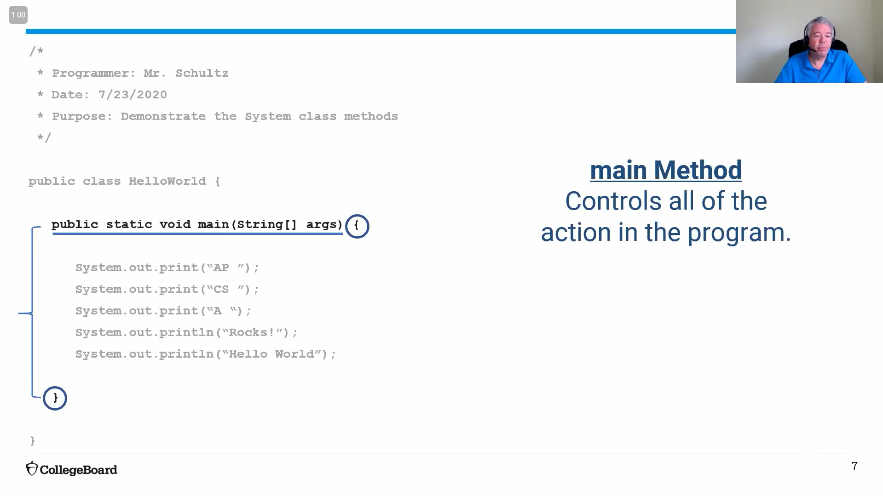

Main method is compulsory to have in Java

**Output**

System.out is the object which generates output to the console

System.out.print() Displays whatever is in the brackets and waits at the end of the line. Does not enter into the next line.

System.out.println() displays whetever is in bracktes but then moves cursor to the next line

System.out.println(“hello world” + b + “!”);

**String literals**

A string literal in Java is an exact sequence of characters (letters, numbers, or symbols) which are enclosed between two quotation marks.

**Errors**

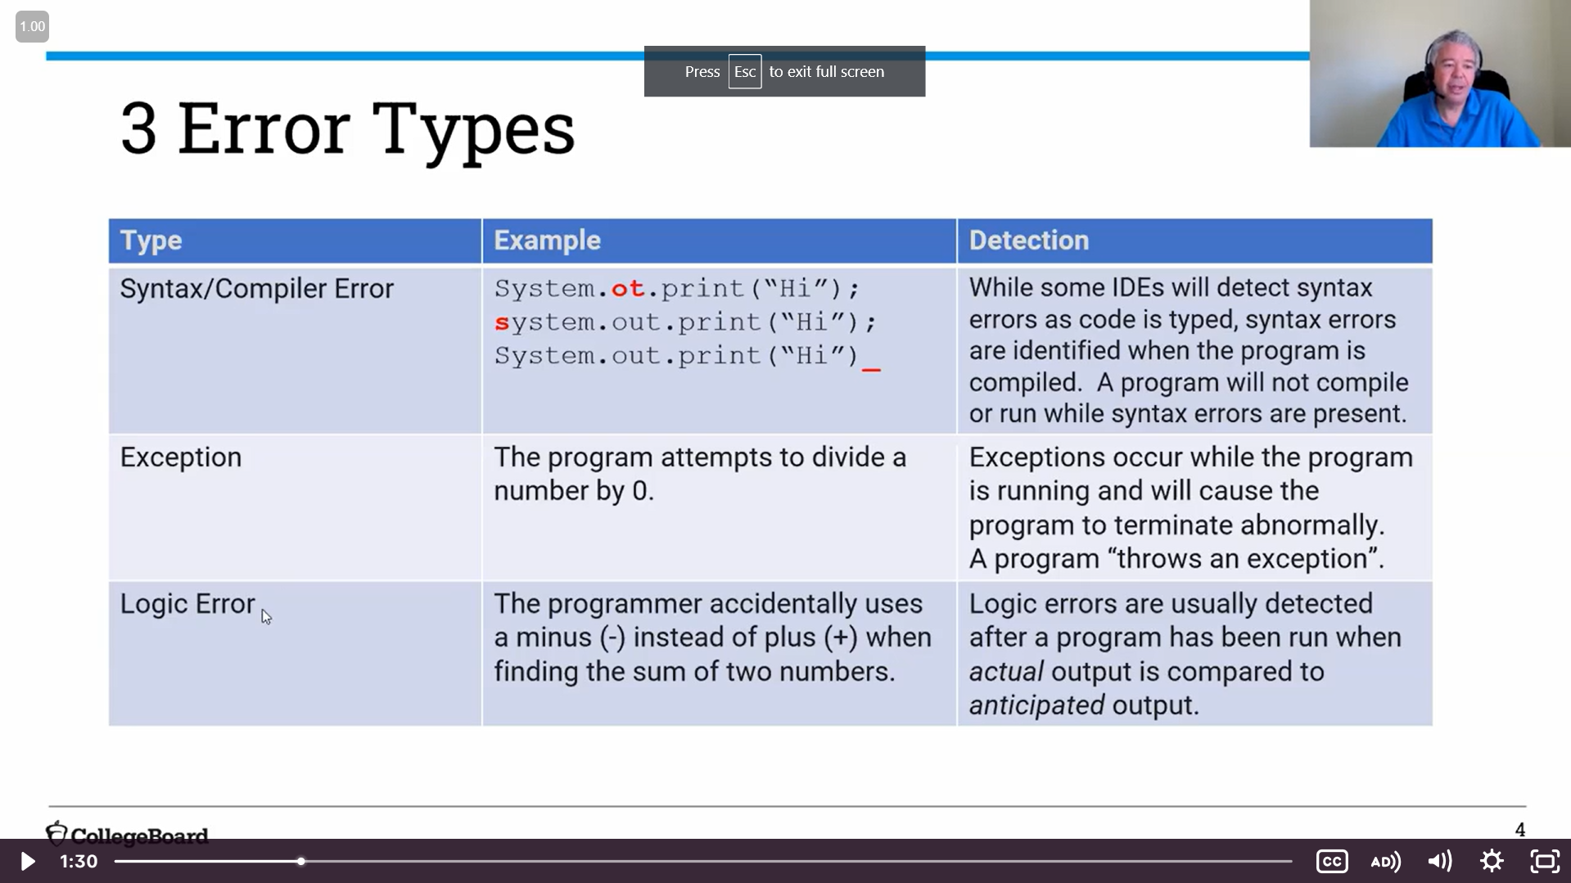

**1.2 Variables and Data types**

1. **Primitive data type:**

Store actual values in memory. Stored in stack memory, which is faster and requires less memory than objects. Variables store their actual values and pass them by value during method calls. When you assign one primitive variable to another. The value of y is copied into x. Both x and y now hold the same value, but they are stored as separate variables in memory. Changing the value of x later will not affect y (and vice versa).

2. **Reference data type:**

Refer to objects and store the memory address (reference) of the object they point to, rather than the actual value. Reference types store a reference (memory address) pointing to the object in the heap memory. Reference types pass the reference during method calls. When you assign one reference variable to another. Both str1 and str2 will point to the same object in memory (heap). This means changes to the object referenced by str2 will also reflect when accessing it via str1, because both variables refer to the same memory location.

**Primitive data types**

Determines the size and type of information

1. Boolean: True or false. Take up 1 bit.
2. int: whole numbers. take up 32 bits. Range: 2147483647 to -2147483648 (Need to learn these values or atleast the number of digits since may ask if there will be error)
3. double: floating-point numbers. Take up 64 bits. Range: 14-15 digits

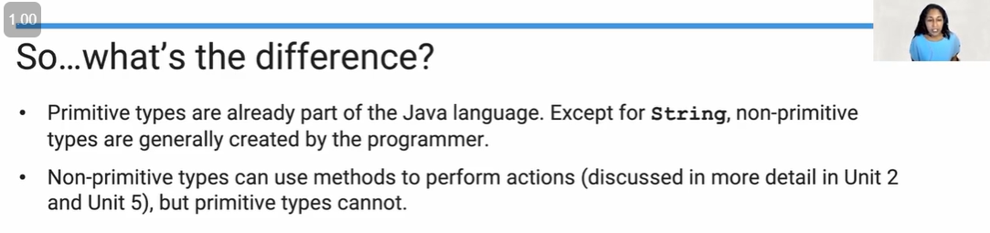

#String is not a primitive data type. It is a **reference data type**.

**Variable:** A variable is a name given to a memory location that is holding a specified type of value.

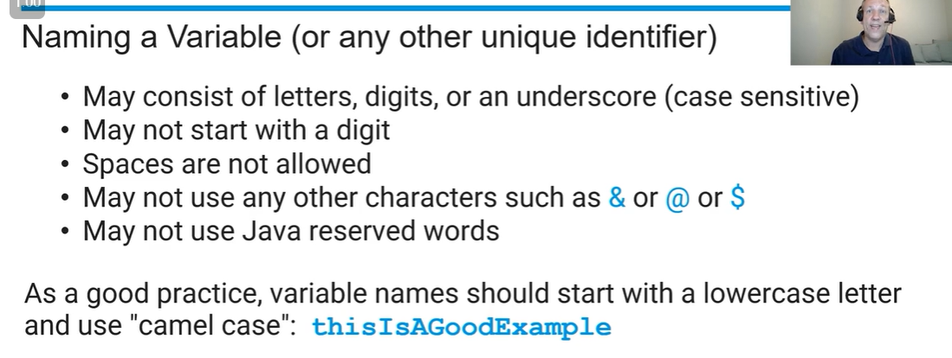

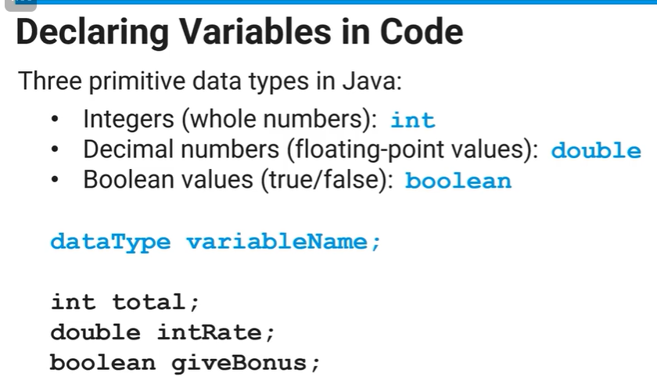

#double b=6; here b becomes 6.0.

#BUT int b=6.0; will raise an error

#In java, once you declare a variable as int d; we can’t give it value of any other data type not even float but we can still do int d =4; d=5; We can change the value of d as long as it is of the same data type.

**final keyword**

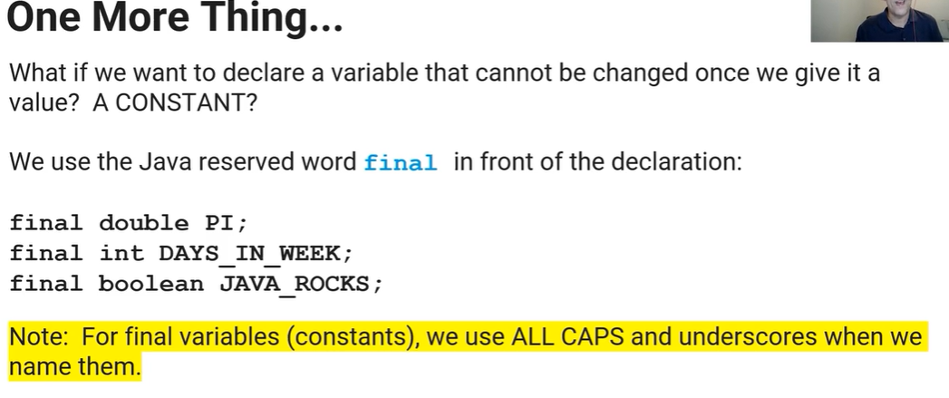

If we do final int d=4;

and then d=5;

it will raise an error since once we say final we can’t change its value even if it is of the same data type.

**1.3 Expressions and assignment statements**

A literal is the source code representation of a fixed value.

Arithmetic operations:

1. +: addition
2. - : subtraction
3. * : multiplication
4. / : division (remember a backslash)
5. % : modulus gives remainder

if we have two int operands result is always int. (1/2 will give 0 not 0.5)

if we have two double operands result is always double (1.0/2.0 will give 0.5)

if we have mix (int and double) then we get the bigger data type. since double is 64 bit we get double. (1.0*2 will give 2.0)

int a=9;

double b=9.8;

int x= a+b;

This will raise an error since x has to be double.

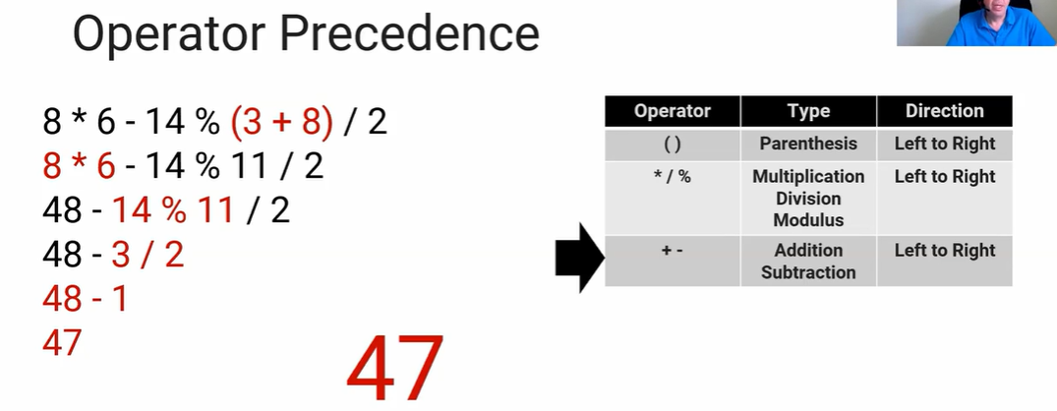

We can store int x=8; and then do x*6-14…

**Assignment operator**

‘=’ is an assignment operator

It instructs java to assign the *value on the right* to the *variable on the left*.

x=7 is legal

7=x is wrong

Assignment operator’s precedence is after arithmetic operator and is from **right to left** ie if we have x=y=z=7 first z gets value of 7 then y gets value of z and then x gets value of y.

**1.4 Compound assignment operator**

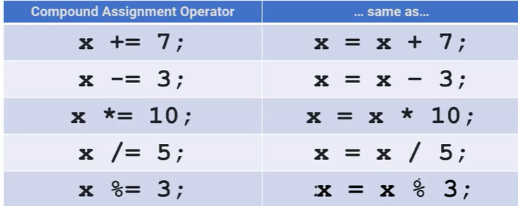

**Increment/decrement operators**

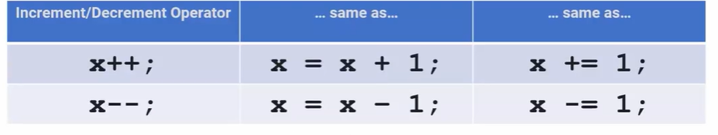

It takes the value stored in x. Adds/subtracts it by one. Assign the result back to x.

there are two things ++x and x++ but for AP CSA we just need to know x++.

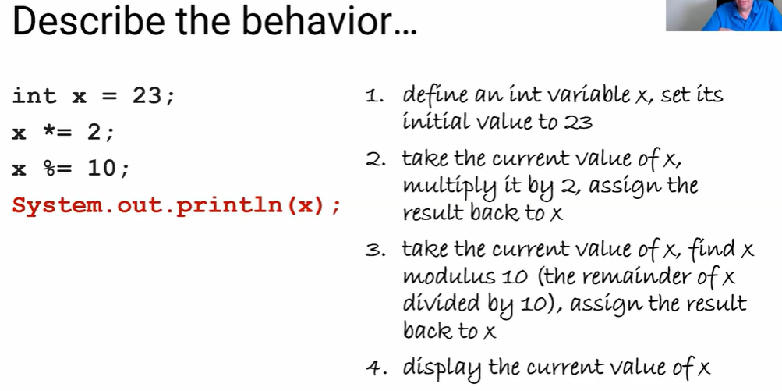

Idk this may be asked. This is what describing the behaviour of the code means.

**1.5 Casting and Ranges of variable**

**Casting:** Used to change data type of variable from one type to another

(double) or (int) is used

Eg: System.out.println((double)6/4); OUPUT: 1.5

However here the original data type of variable cannot be changed with casting.

Eg: int a=6;

a=(double)a;

This will give an error since we can’t change data type of a from int to double.

However, we can do this

int a =6;

double b;

b=(double)a;

System.out.println(b)

OUPUT: 9.0

#double b=6;

double c = (int)b;

No error in this statement. C gets the value of 6.0.

Basically, if we give a double an int value it will make it double but if we give int a double value we get error.

#When we convert double to int it doesn’t round it off just removes the decimal numbers.

#If we do String r = “str1” + 0.23 then r=str10.23 since java converts int/double to string when it is concatenated.

**Rounding off**

Positive number: int(number+0.5);

Negative number: int(number-0.5);

**2.1 Objects and Classes**

**Class:** A class is a blueprint for creating objects with the same behaviour and defined attributes

**Objects:**

An object is a specific entity, made from the blueprint or class, that you can manipulate in your programs.

Objects are individual instances of classes with variables used to name them.

Each object has behaviours and attributes that are defined by the class that was used to create it.

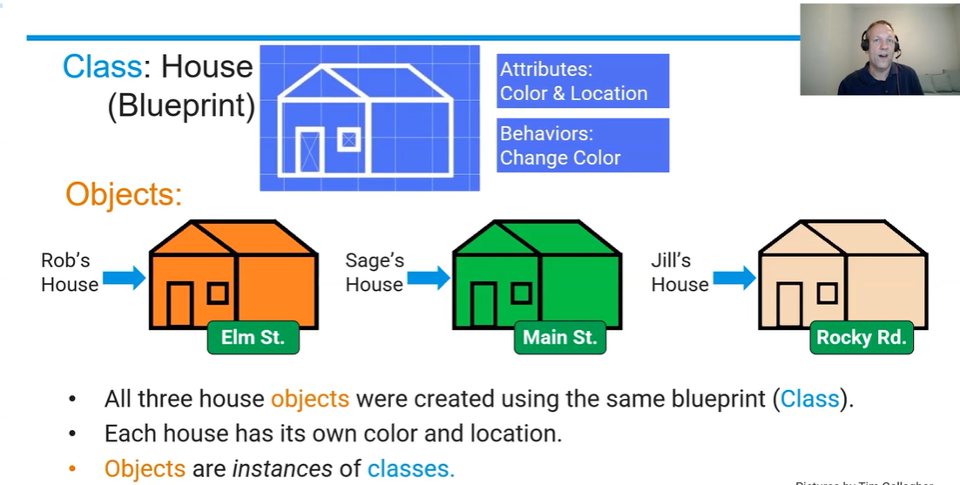

* Two variables can refer to one object. If jack also lives at jill’s house we can refer to that object (house) as Jack’s or Jill’s. And if we change attribute (colour) of Jill’s house. Attribute of Jack’s house also changes.

**2.2 Creating and Storing Objects (Instantiation)**

**Objects**

Objects is a reference data type that holds data known as attributes and can perform actions known as methods.

**Constructor:** In Java, a constructor is a special method used to initialize the attributes for an objects. It is called automatically when an object of a class is created.

Sets initial state of object which include initial values for all instance variables.

* Same name as class
* Always start with public

// Defining a class named Example

public class Example {

// Instance variables (attributes)

int number;

// Constructor

public Example (int num) {

number = num; // Initialize with given value

}

// Main method for testing

public static void main(String[] args) {

// Create an Example object using the constructor

Example obj = new Example (10);

}

}

Here the constructor is public Example (int num){} since this line is initializing the object.

#remeber number=num not num=number because in Java, it is the left value that gets updated and we want to update the instance variable which is number.

**No argument constructor:** Has no parameters and sets the instance variables for the object to default values which is defined in the constructor.

public Example () {

number = 0; // Default value

}

If we do no give number a value. It will get the default value of the datatype.

**Formal parameters:** public Example (int num); Here int num are the formal parameters

**Actual Parameters***:* Example obj = new Example (10); Here 10 is the actual parameter.



Creating the Object: - This happens when you use the new keyword. This creates a new object and calls the constructor.

For example: Example obj = new Example (10);



= variable type



= object name



= Constructor



= Actual parameters



Initializing the Object: - Once the object is created, the constructor is automatically invoked to initialize its attributes or perform setup tasks. In the example above, the constructor Example (int num) is called to assign the value 10 to the number attribute.

* To access an attribute of the object. We write objectname.attribute. Eg: obj.number. We can also define a method inside an object than call it by objectname.method()
* To change attribute, obj.number=10;

#If no constructor is defined, Java provides a default constructor where all variables are set to default values. 0, 0.0 and null for int, double and objects like strings respectively.

**Signature:**

A signature is the unique identifier of a method or constructor based on its name + parameters (type, number, and order).

No two methods can have the same signature.

For public Example (int num) {}, the signature is Example(int)—it identifies this particular constructor based on its name (Example) and parameter list (int).

**Overloading Constructors:** When we have more than one constructor for an object. Different constructors to handle the different ways one may want to create and object.

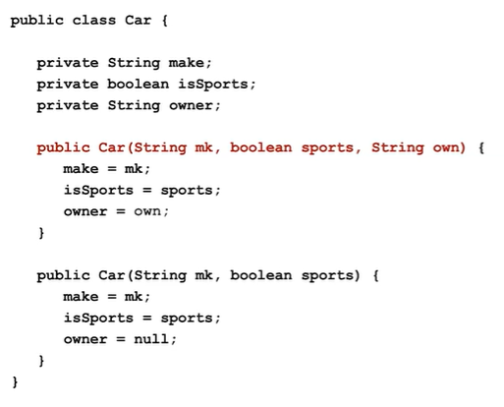



Car car_object1 = new Car(“Audi”, true, “Susan”); This will call constructor 1 since the type and number of parameters match.

Car car_object2 = new Car(“Audi”, false); This will call constructor 2. Here since owner variable is given the default value of null. Even if we didn’t specifically write owner =null, owner variable will get default value of String which is null.

**#**Car car_object3 = null; Here only a memory and space is created for this car to exist. It is not initialized (=new Car()). Now if we had a method lets say turnOn() in this class and we tried to car_obj3.turnOn(). We will get error.

#The parameters in the constructor like mk is local only to the constructor. They cannot be used anywhere else inside the class.

**2.3 Methods**

**Methods:** Methods define the behaviour of all objects of a class and consist of a set of instructions for executing behaviour.

It is basically a block of reusable code that is executed when it is called

Syntax:

datatype name (parameters){

}

The datatype is the datatype of the value it returns.

If we are not returning anything we write void.

We can’t use variables defined in one method in other method. We can pass it thru as arguments.

return works the same as python. If a method is returning something we can assume that where ever we are calling that function we just replace it with that return value. Also after the return statement the code stops running for that method. This can be used as break. We can just write return; in void methods and the code will break after the statement.

If (condition){

Return -10

}

Return -5

If condition met then it will return -10 otherwise -5.

**Method Signatutre**: Same as constructor. Name + parameters

**Overloading:** Same as constructor. Name can be same. Signature has to be unique

**Method header**

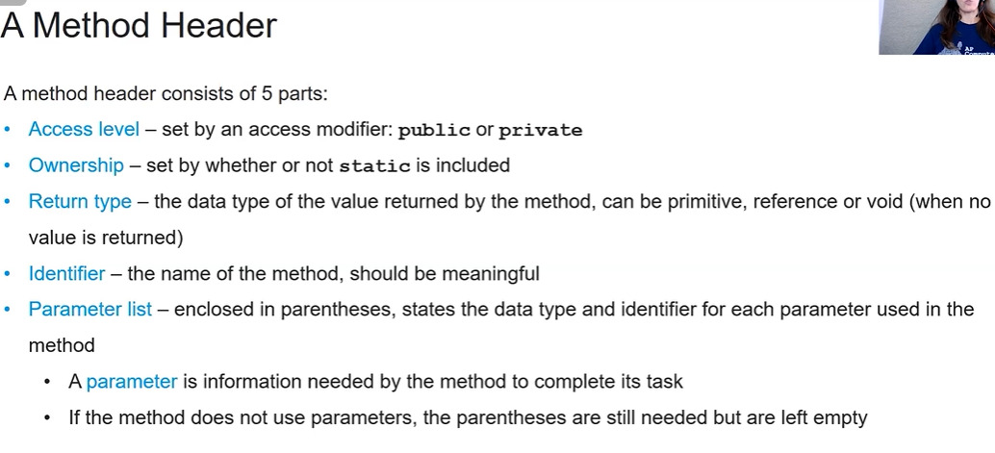

**Static**

* Used to indicate that a particular member (variable, method, block, or nested class) belongs to the class itself, rather than to any specific object of the class.
* member can be accessed without creating an instance of the class (object).

1. Static Variables: They belong to class and all objects share this variable, meaning there is only one copy of the variable, no matter how many objects are created.

public class Example {

static int counter = 0; // Shared across all objects

public Example () {

counter++;

}

}

public class Main {

public static void main (String [] args) {

Example obj1 = new Example ();

Example obj2 = new Example ();

System.out.println(Example.counter); // Output: 2

}

}

If we hadn’t used static here the output would have been 1 since each instance of class or each object would have created a different copy of the variable.

Also if we hadn’t used static we can’t sout Example.counter we would have to sout ob1/ob2.counter, since the variable belongs to the object not the class itself.

1. Static method:

Can be called without creating an instance of the class.

Can only access static variables and other static methods but not instance variables because non-static belong to an instance of the class (object).

So, to decide whether one method should be static or non-static we first need to see what kind of data does it need: static variables or non-static variables.

public class Example {

static void greet() {

System.out.println("Hello, this is a static method!");

}

}

public class Main {

public static void main(String[] args) {

Example.greet(); // Directly calling the static method

}

}

If the method was non static then we would first have to create an object. Example obj1 = new Example(); and then obj1.greet();

**#**public class Main {

//defining a class Employee

public static class Employee{

String name;

//Method

void non_static(){

System.out.println("Non static method");

}

// Creating constructors

//Default Constructor

public Employee(){

name = null;

}

}

public static void main(String[] args) {

Employee default_emp = new Employee();

default_emp.non_static();

}

}

* Since default_emp is an instance of the Employee class, it has access to all non-static methods inside Employee.
* non_static() exists inside the class, so Java allows the object to call it, even though it was never mentioned inside the constructor.

1. Static nested class

A static nested class is a class defined within another class, but it is declared as static. Because it is static, it does not require an instance of the outer class to be instantiated.

In the above example if we didn’t use static for the nested class Employee. We would need an instance of Main to create their objects.

Main main = new Main();

Main.Employee default_emp = main.new Employee();

**Public keyword**

The public keyword in Java is an access modifier, which defines the visibility or scope of a class, method, or variable. When something is declared as public, it means that it is accessible from anywhere—inside the same class, different classes, and even from other packages.

* The Main class and main method inside the class has to be public.

**Instance variables**

* Instance variables are the attributes of an object in Java.
* Each object has its own unique copy of the instance variables.
* Declared inside a class but outside any method, constructor, or block.
* If no value is assigned, instance variables are initialized to their default values (e.g., 0 for integers, null for objects).
* Accessible within the class's methods, constructors, or blocks.

Difference Between Instance and Static Variables

* Instance Variables: Belong to objects; each object has its own copy.
* Static Variables: Belong to the class; shared across all objects of the class.

**Scope:**

1. Local: Defined inside a method or constructor such as formal parameters and variables declared inside methods. Can only be used inside the method or constructor and cannot be declared to be public or private (if we do will raise error).
2. Class: Defined outside the method in the class. It can be recognized throughout the class.

Order of precedence is same as python. First checks local scope and then class scope.

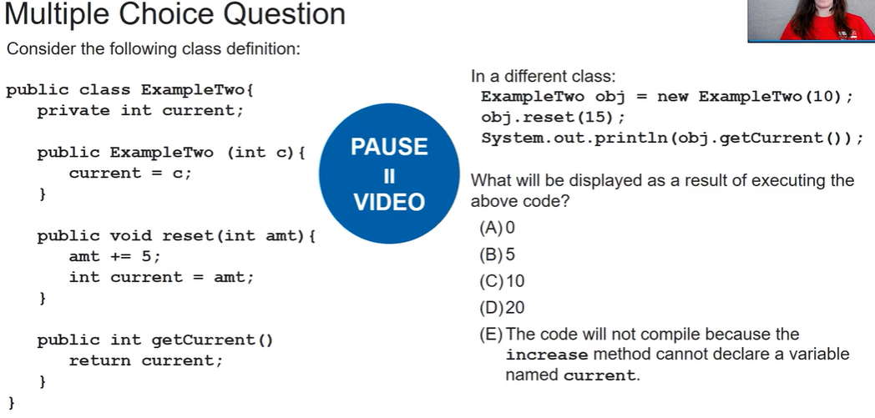

**Ans:** C) 10 since in the reset method we wrote in current so a new variable current (local variable) is formed which only exists only in the reset method. The instance variable current is not changed.

**this keyword**

Within a non-Static method or constructor, the keyword this is a reference to the current object- the object whose method or constructor is being called.

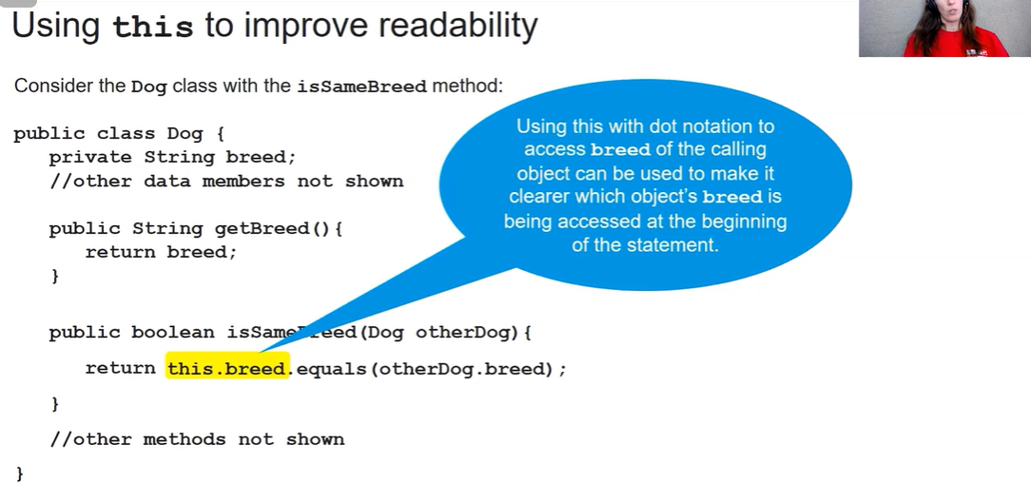

Here, this refers to the calling object (obj1.isSameBreed()). It is optional here and is just written to improve readability.

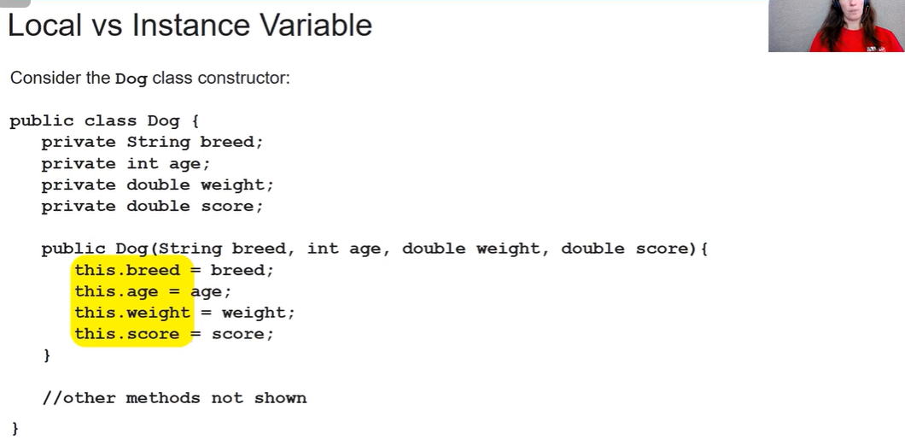

Here we need this. Since local and instance variable name is same and due to order of precedence java will take these variables as the local variables. Taking this.breed specifies that breed is the instance variable.

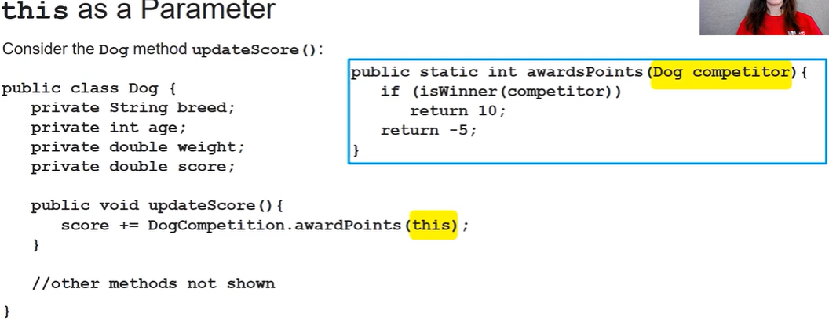

This can be used to pass the current object as an actual parameter in a method call.

**2.6 String**

Can’t use single quotes only double. Single is used for char.

If we are not using an IDE then we might need to import java.lang.String;

Ways to create:

1. String name1 = “Hello”;
2. String name2 = new String (“Hello”/name1);

* Strings are immutable: Methods that act upon string objects do not change the state of the defined String object.

**Concatenation**: Joining of data

* +: Joins
* += Joins and redefines.

Primitive variables like int and double can be added to strings and they are implicitly converted to strings.

In concatenation, strings are added in the order they are written.

**Escape sequences**

The start with a \ backslash (the one above enter)



Trick: Imagine climbing the slope. If you are going backwards then it is backslash and if you are going frwd then forward slash.

For CSA we have 3 escape sequences:

* \” : prints a double quote
* \\ : prints a backslash
* \n : Inserts a new line

**2.7 String methods**

**Indexing:** Same as python. Starts from 0.

**s.indexOf(“subs”):** Gives an int value of the first index where the substring is found in the string. If substring not a part of string then it returns the value -1. If the substring is not a single string but smth like ‘app’ then indexOf gives first value where app is found. If s is apple then it will give 0.

**s.substring(start index, stop index):** Gives a string which is a substring of the original string starting from the start index to the stop index-1. If we don’t write stop index it will go till end. If str=” hello”. Index ends at 4. But since substring doesn’t include the last index, we can write str.substring(0,5) it will not give error. But if we do (0,6) then it will try to find index 5 which will raise and error. If we do (5) it will not raise error and return empty string but (6) will give error

**s.length():** Gives an int value of the total number of characters in the string

**s.equals(str2):** Returns Boolean value. True if s is equal to str2 and false if s is not equal to str2. First string (s) is known as *this* and 2nd string (str2) is known as *other.*

**s.charAt(index):** returns character at specified index.

**String.valueOf(x):** converts int, decimal, Boolean and null into string. For objects returns the memory location or the object if toString() method is modified. Also String.valueOf is needed with capital s. We don’t put our string variable in place of String. String str = String.valueOf(47);

**Q)** Difference between .equals() and == operator?

> The == operator works differently for different data types:

* Primitive data type (int, double): it compares the actual values stored in the variables
* Reference data type (string, objects): compares the memory locations (references) of the objects, not their content.

So even if str1 and str2 have the same content ("Hello"), they are stored in different memory locations, so == returns false.

But .equals() method checks the content not the reference or memory location

String s1 = “Hello”;

String s2 = new String(“Hello”)

String s3 = “Hello”;

s1.equals(s2): True since only content is compared

s1 == s2: False since memory location different

s1 == s3: True since this is a special case. When making string with string literals, java uses the string pool to optimize memory. Strings with the same value are stored only once in the pool, and all references point to the same object.

**this.compareTo(other):** Return int value

return <0 if this is less than other

return 0 if this is equal to other

return >0 if this is greater than other

The value it return is decided by the Unicode values. It compares character by character. If there is a difference in character then it returns the difference of the Unicode value with the respective sign given by above rules. If all characters are same and only length diff (like ‘help’ and ‘helps’) then it returns the number of extra characters irrespective of what those characters are. If there are four extra characters it will give 4 again with the respective sign irrespective of whether the four extra characters are s or d or anything.

**2.8 Wrapper Classes**

Integer and Double are wrapper classes

**Integer**

Integer is a class whereas int is a primitive data type

**Constructor:** Integer int1 = new Integer(169);

**x.intValue():** The intValue() method in Java is used to convert an instance of a numeric wrapper class (like Integer, Double, Float, etc.) into its corresponding int primitive value.

For a Float or Double object, the value is cast to an integer, meaning the fractional part is ignored.

BUT if we define double x = 9.9; and then we do int i = x.intValue(); It will give error

We need to define x by Double class. Double x = new Double(9); Now it will output 9;

This will not work with Strings.

**Integer.MAX_VALUE & Integer.MIN_VALUE:**

There is a limit to what values they can hold ie they have a max and min value which can be found by

Integer.MAX_VALUE; Integer.MIN_VALUE;

Double.MAX_VALUE; Double.MIN_VALUE;

int a = Integer.MAX_VALUE;

int b = Integer.MIN_VALUE - 1;

System.out.println(a+1 + “ ” + b-1);

It will not give an error but it will not give desired output we will get some weird value. This logical error is known as overflow error.

BUT

int a = 88888888888888888888888888;

Will not compile and give an error that int is too big.

**Double**

Double is a class whereas double is a primitive data type.

**Constructor:** Double score1 = new Double(2.087);

**x.doubleValue():** It is a method of all numeric wrapper classes (int, double, float etc). It converts value into primitive data type double value.

BUT if we define int x = 9; and then we do double d = x.doubleValue(); It will give error

We need to define x by Integer class. Integer x = new Integer(9); Now it will output 9.0;

This will not work with Strings.

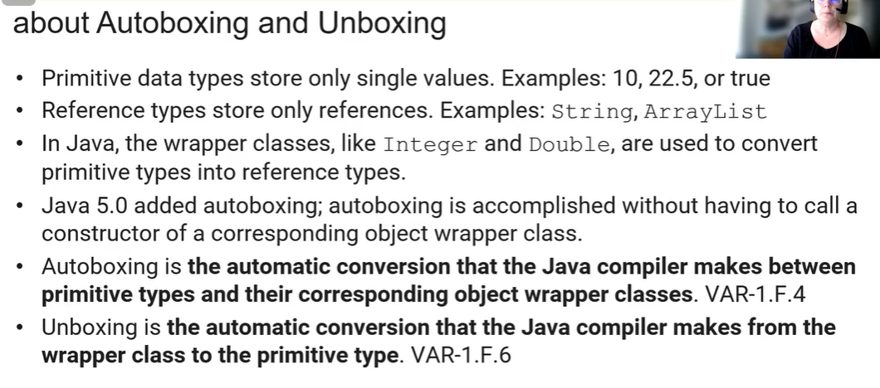

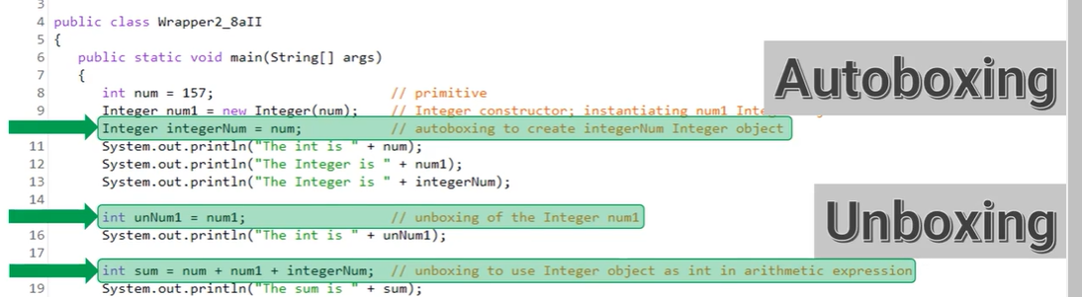

**2.9 Math class**

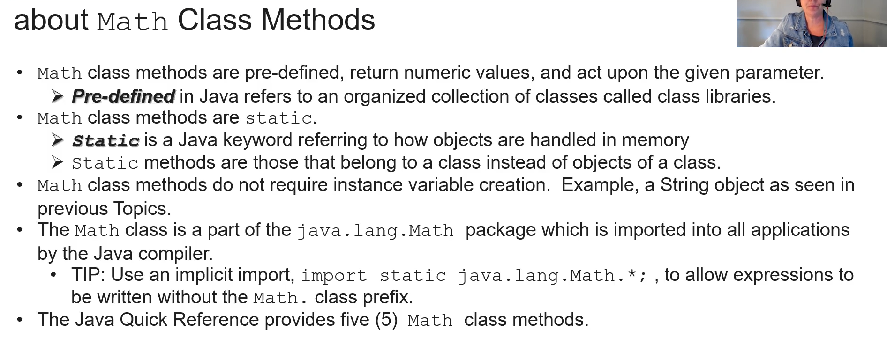

**Math.abs(-1):** Gives absolute/mod of number. If we enter int value we get int number and if enter double value, double value is returned.

**Math.pow(base, exponent):** Always returns double since the parameter are taken as double even if we enter int or double. Math.pow(1,2) will give 1.0

**Math.sqrt(49):** Gives square root. Always return double since parameter is converted to double. Here it will give 7.0.

**Math.random():** Returns a random double number which is greater than or equal to 0.0 but less than 1.0 (i.e. it includes 0.0 but not 1.0)

# If we need random integer we can multiply with 10 or 100 or whatever is needed and then cast it into int with (int).

# We can also add or subtract necessary numbers to get the needed range. Like if we add 1 to above example our range now becomes 1 to 100.

# If we multiply by 6 or 7 to see range multiply it with highest (0.999) and lowest(0.0) range to get the new range. If by 6 lowest = 0.0 and highest = 5.999

#It can also be used for probability. If <0.2 then 20% chance

<0.5 then 50% chance

<0.75 then 75% chance

# IF we want 0-n we need to multiply random by n+1 cuz 0.9999 into n+1 would n.8999 and (int) that will give us n.

**3.1 Boolean expressions**

**Relational operators:**

1. == equal to
2. != not equal to
3. < less than
4. > greater than
5. <= less than equal than
6. >= greater than equal than

Relational operators evaluate to Boolean expressions either true or false

# Use == and != only with primitive data type. For reference or String use .equalTo() or .compareTo() etc.

**3.2 If statements and control flow**

If statements are known as *one way selection*

if (condition){

statement

}

Brackets compulsory

The curly braces can start from next line as well.

If inside if or else there is only one line of code we do not need the curly braces. If we don’t use curly braces and use 2 or more statements only the first statement will be considered in the if block and other statements will be considered outside the if block.

Java doesn’t care abt indentation.

**User inputs**

User inputs is done by Scanner class which we need to import above everything even the Main class.

import java.util.Scanner;

Then inside main() we need to make a Scanner object.

Scanner sc = new Scanner(System.in);

Sout(“Enter details: “);

String name = sc.nextLine(); //Inputs the whole sentence including spaces

String first_name = sc.next(); //Inputs only the first word

int age = sc.nextInt(); //Inputs int (if double entered then it will throw error)

double gpa = sc.nextDouble(); //Inputs double (if int entered it will convert to double)

boolean isStudent = sc.nextBoolean(); //inputs Boolean (error if any thing other than true or false filled) (also doesn’t matter if filled upper or lower case)

**Problem**

There is an issue when expecting an int or double and then accepting a string. This is because after hitting enter after inputting an int/double it still has /n character and the nextLine reads this /n character and weird stuff happens

To solve this, after inputting int or double just call nextline() without assigning anything

Eg: System.out.println("Enter your age: ");

int age = sc.nextInt();

*sc.nextline();*

System.out.println("Enter your name: ");

String name = scanner.nextLine();

System.out.println("Hello " + name);

System.out.println("You are " + age + " years old");

Best practice to close after program. sc.close();

**3.3 If-else**

If-else statement is a two way statement.

if (condition){

statement

}

else {

statement

}

**3.4 Else-if statement**

Multi way selection

if (condition){

statement

}

else if (condition){

statement

}

else {

statement

}

There can be as many else if we want.

Whichever condition satisfied the rest are not

**3.5 Nested if**

**Dangling else**

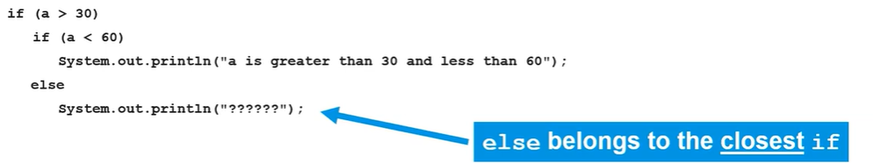

Since indentation don’t matter in java the else will go to the closest if without a else.

This can be solved by using curly braces

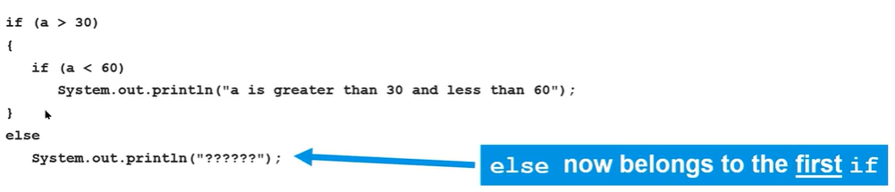

**Logical operators:**

1. ! not: result to the opposite value of what a currently is
2. && (and): result in true if both a and b are true.
3. || or: Result in true if either a or b is true.

The above order of precedence is used

**Short circuited evaluation**

Occurs when the Boolean expression does not need to be fully evaluated to determine the result. For && it happens when first half is false

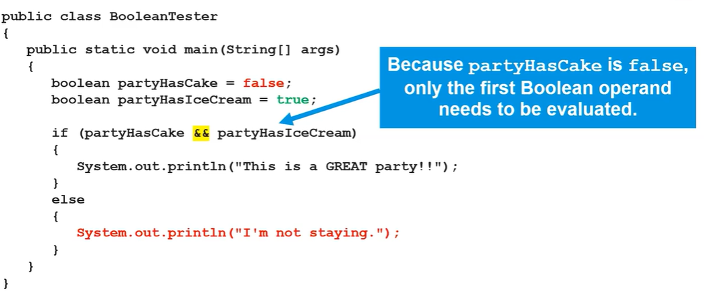

Java itself doesn’t evaluate the second expression

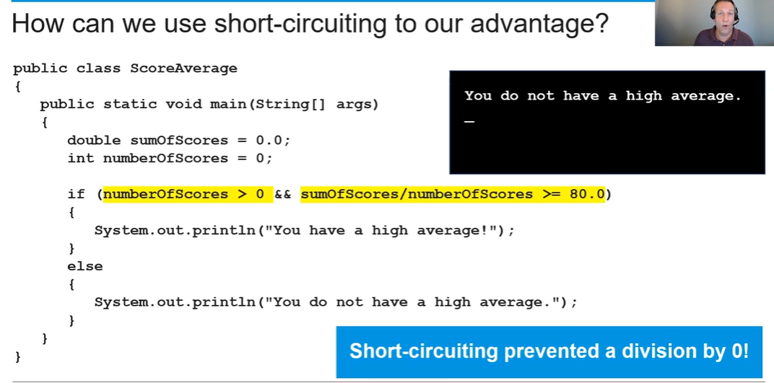

Since first part is false it doesn’t evaluate the second part and does not raise an error.

**3.6 Equivalent Boolean expression**

**De morgan’s Law**

1. ! (a $$ b) = !a || !b
2. ! (a || b) = !a $$ !b

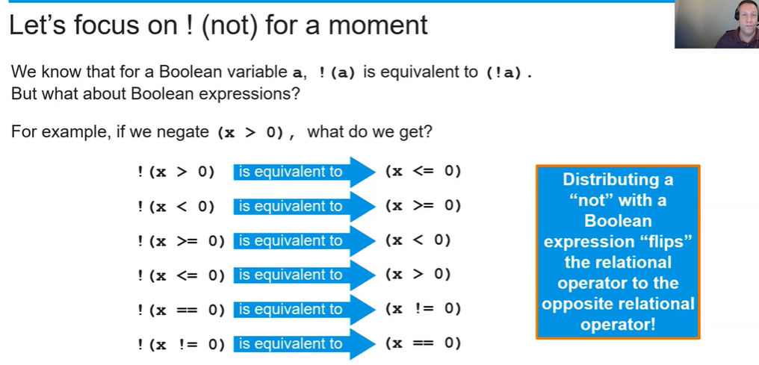

**Truth Tables**

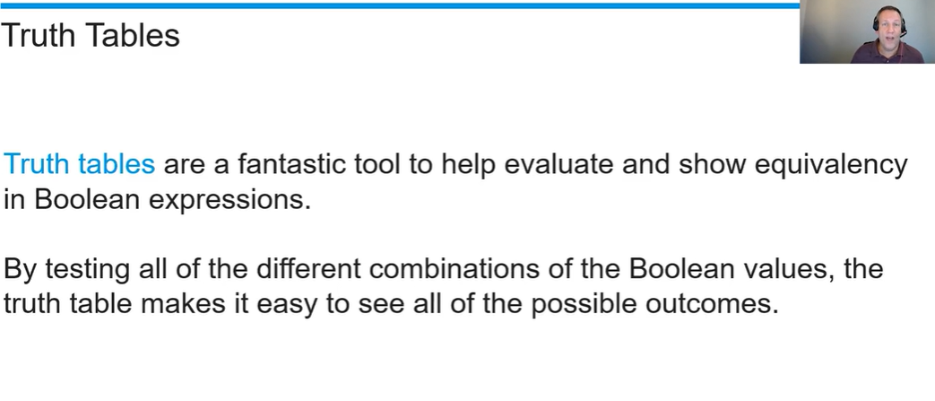

**3.7 Comparing Objects**

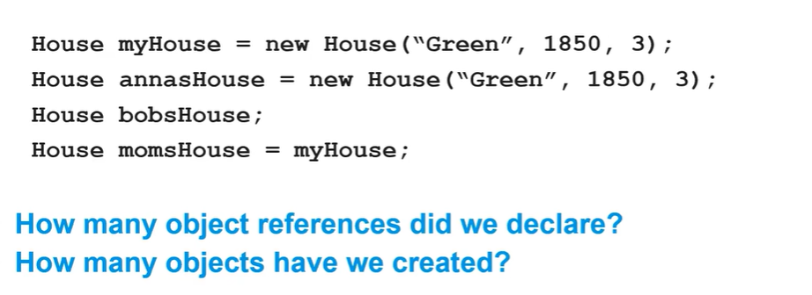

We created 4 object references.

We only created 3 objects myHouse, annasHouse and bobsHouse. momsHouse is just another reference for myHouse. It is a variable that points to myHouse only.

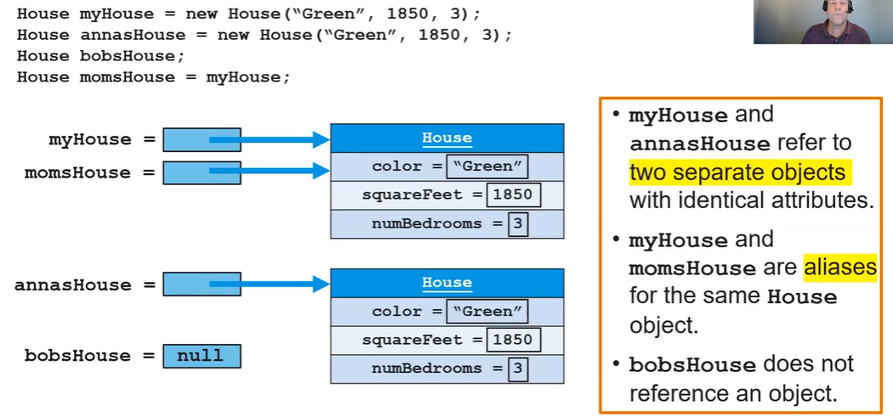

== for objects only see references not values. So, myHouse=momsHouse is true but annasHouse == myHouse is false.

bobsHouse == null will be true

#For comparing we can use equals() method like we saw in strings. It compares the attributes and value

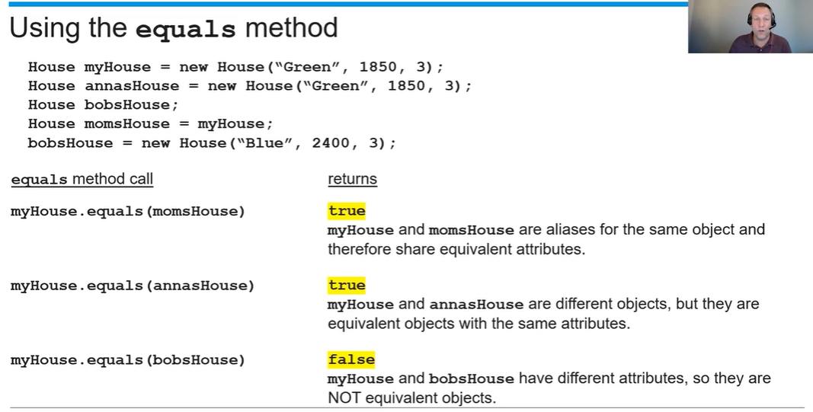

**4.1 While loops**

Loops are repetition of a set of statements. The Boolean expression is evaluated before the loop including the first time. It runs until it evaluates to false after which the iteration ceases.

while (Boolean expression) {

statements

}

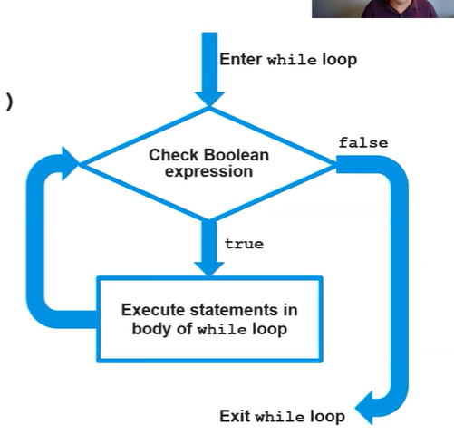

**Loop control variable**

First initialize the loop variable outside the while loop. Check condition in Boolean expression and update it inside the loop. Where you place the updating inside the loop can effect the output.

**Infinite loop:** A loop which runs infinitely because the Boolean expression always evaluates to true.

**Standard algorithms with while**: Check std_alg file

**4.2 For loops**

for (initialization; Boolean expression; update;){

statements

}

Initialaztion statement only runs once before the first Boolean expression. The variable being initialized is known as *loop control variable*. In each iteration, the update statement is executed after the entire loop body has executed and before the revaluation of the Boolean expression.

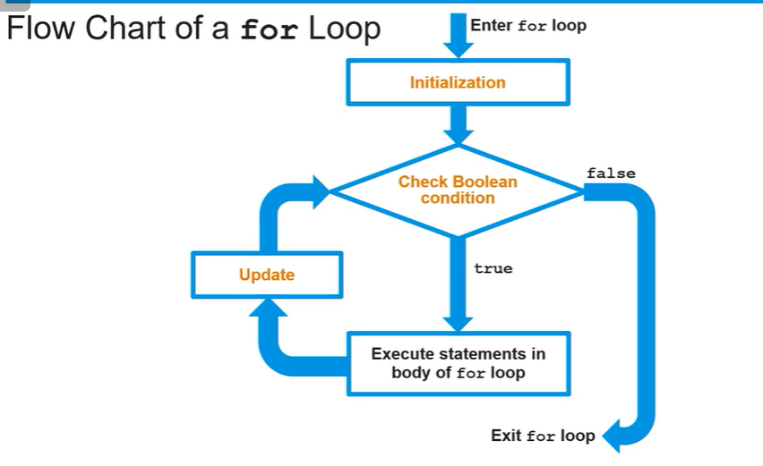

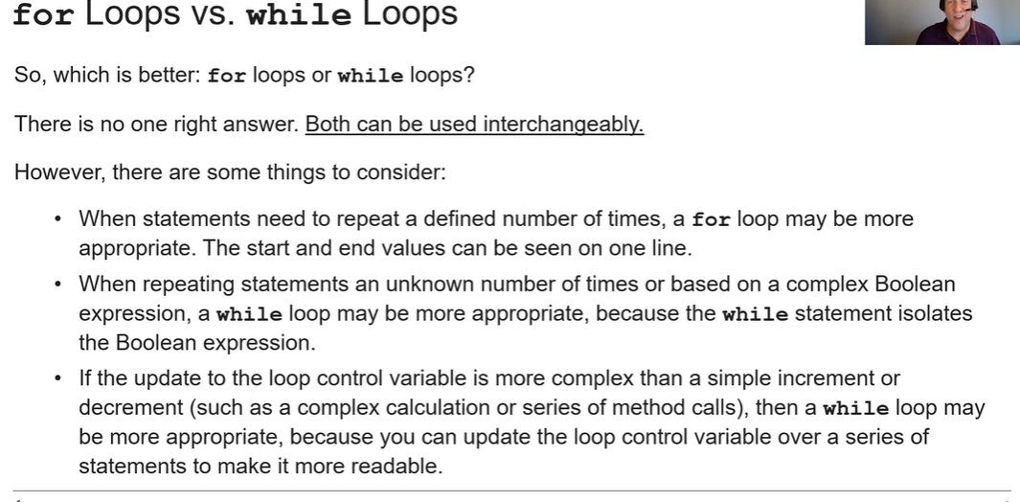

**Off by one error:** iteration loop occurs one time to many or one time too few.

**String algorithms:** Check std_alg

**Nested loops:** First inner loop iterations are completed and then only the outer loop can continue.

In the pattern questions, outer loop controls number of lines while inner loop controls the amt of elements in each line.

Statement execution time is the number of times a statement is executed by the program.

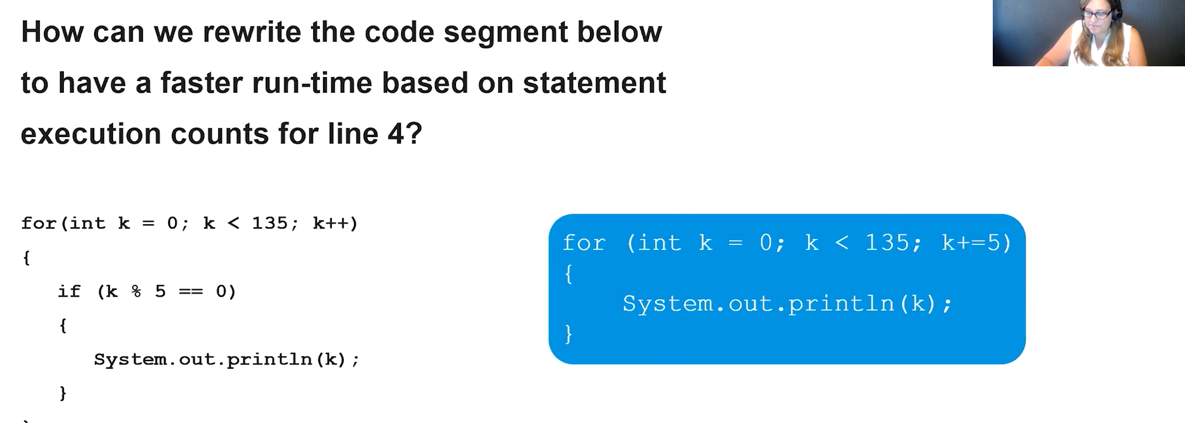

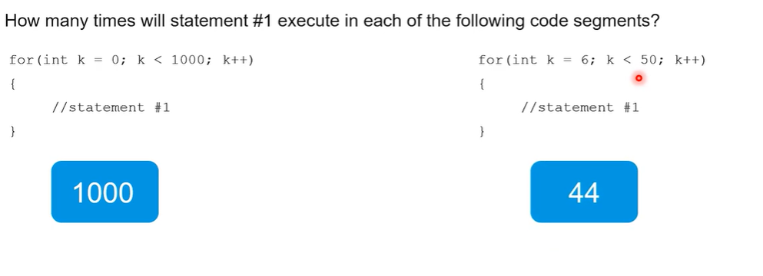

50-6. This is only when < or > if <= or >= then we need to add one.

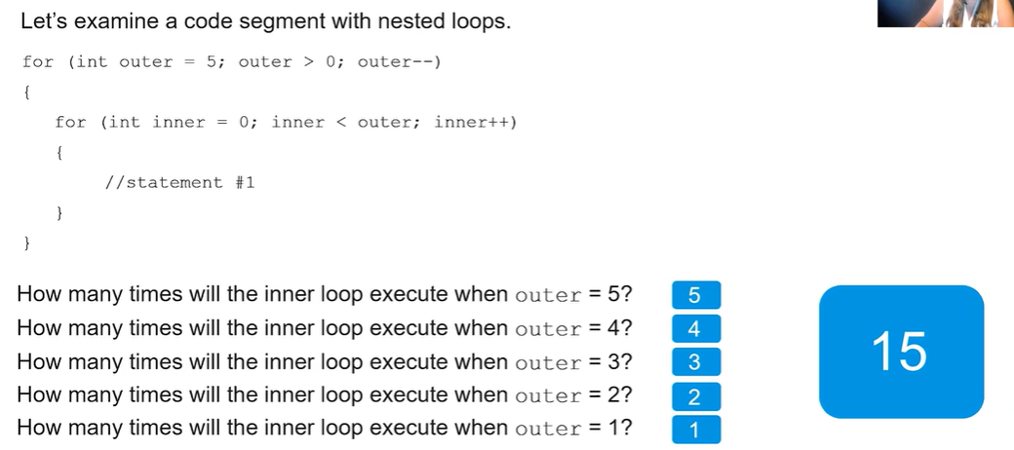

**5.1 Anatomy of a class**

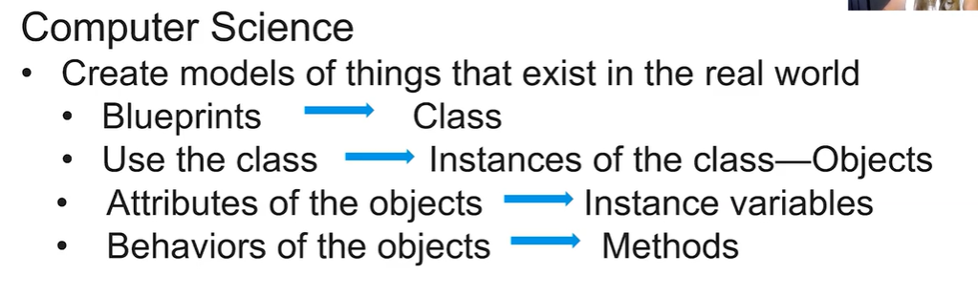

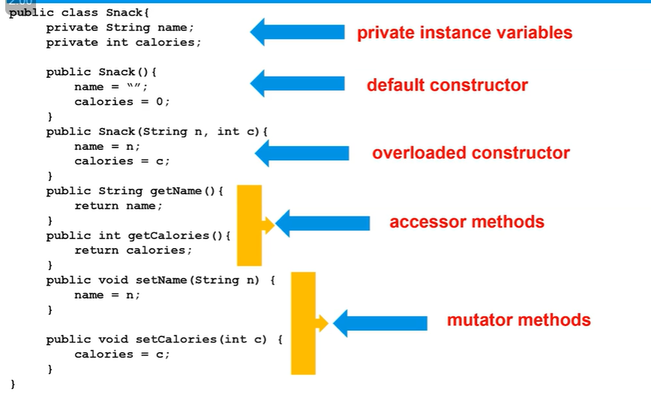

# Name of class in capital

**Public:** there is no restriction on access. Other classes can access. For AP CSA, classes and constructors will always be public.

**Private:** Restricted access. Only access in given class. For AP CSA, instance variables will be private.

**Scope of private variable in nested classes**

Let us see we have a parent class Main which has two nested classes Employee and Hello and a main method. We have a private variable name defined in the employee class.

1. Obviously, it has full access within the employee class
2. In Java, the parent class (enclosing class) has privileged access to all members—including private variables—of its nested classes. And since the main method has been declared in the parent class, name variable can be called in the main method.
3. the private variable name in Employee cannot be accessed directly in the Hello because class sibling nested classes are treated as separate entities and private restricts access only to the declaring class (Employee). To access it in Hello class create a public accessor method in Employee which return name and then call it in Hello class.

#Methods can be private or public. An object can call a public method in any class. Private methods can only be called in their own class.

**Encapsulation**

Encapsulation means bundling data (attributes) and the methods (functions) that operate on that data into a single unit, a class, and restricting direct access to some of its components.

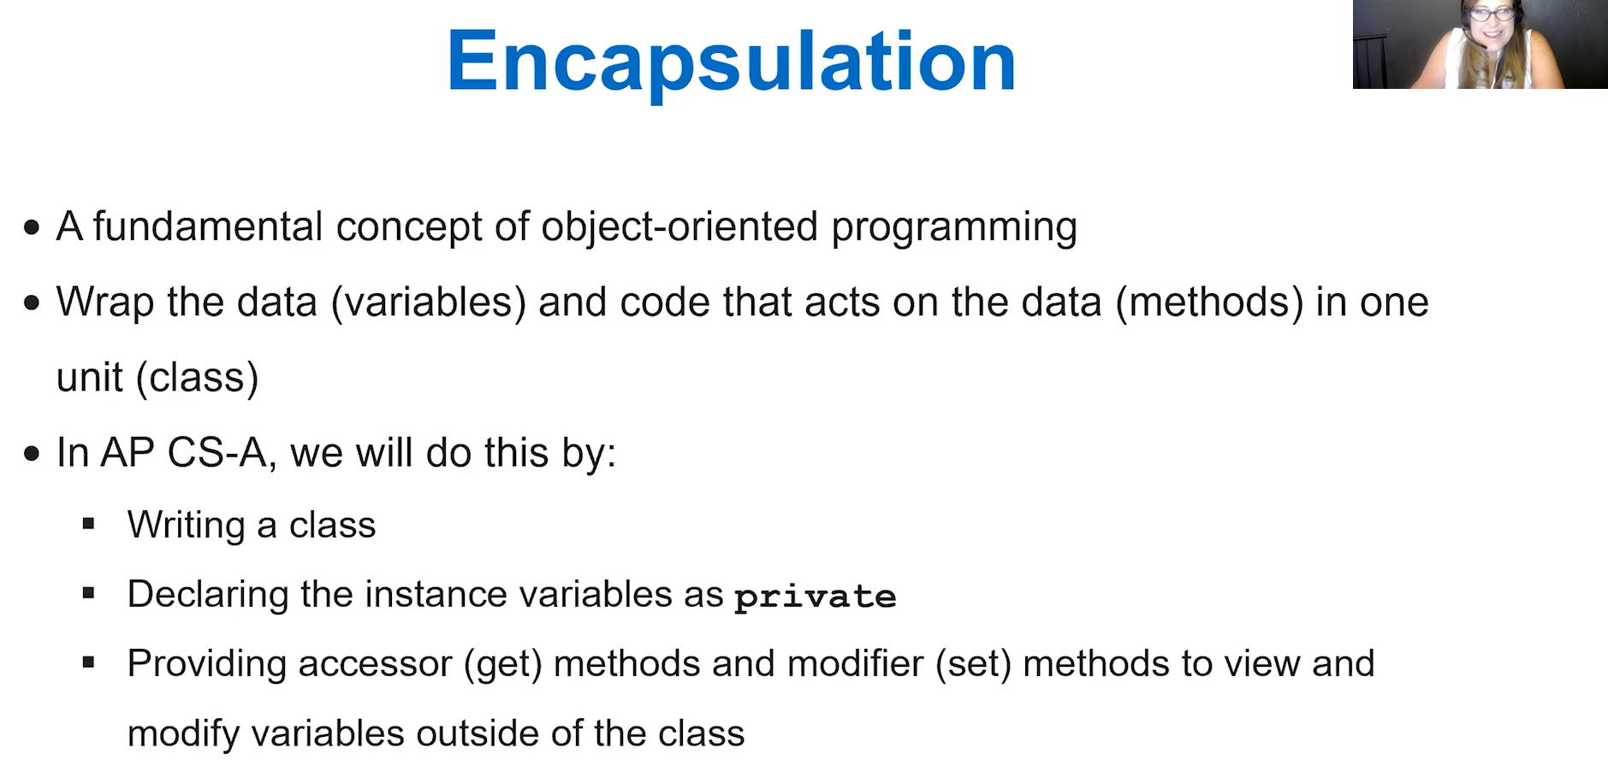

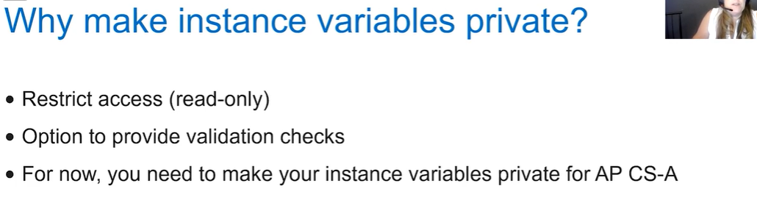

**Comments**

* Ignored by compiler/interpreter
* There to make code more readable for humans
* Not required to write comments in the FRQ

Types:

* Single line comments: //
* Multiline comments: /* */
* /**Documentation

*comment

*to create Javadoc*/

Javadoc is a documentation tool in Java that allows developers to generate HTML-formatted documentation from comments written inside their Java code. Basically creates a hmtl webpage which can be run with cmd which contains details and explains abt your code with what you have written inside the Javadoc comments.

**Pre and post conditions**

In FQRs we will find pre and post conditions comments.

Preconditions: This is a precondition that needs to be true for the method. We basically assume those preconditions are true when we are writing that method. We DO NOT need to check for these preconditions.

Postconditions: Conditions that must be true after the method is executed. That is the code must be written to meet the postconditions and we do not violate any of these conditions.

**Accessor methods/getter:** Used when a different class needs to access the instance variable. We make a public method in Employee class which returns name and the call it in the Hello class. Needs to be public (obv).

**toString() Method**

If we create an object, and sout it then we get random shit like object#6786hb76. To solve this we can create our own toString() method. It returns a string with information about instance variables. When sout is called on object this toString() method will actually run and returned srting will be printed.

In the class employee,

public String toString(){

return "Name: "+ name +"\nSalary: ";

}

In the main method, create object emp1

Sout(emp1) will display the return string.

**Mutator Method/Setter:** Usually a void method that changes the values of instance variables outside of class. If variables not set to private then we could emp1.name = “new name”. But since this variable can only be used in the same class we need to define a setter. It will be public void method where name=”new name” parameter. Then just call it in main method and give new name as the parameter.

**Primitive data type during method calls**

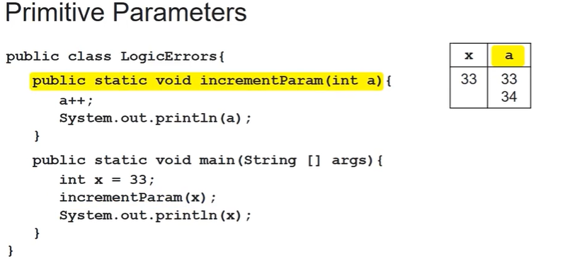

When a primitive data is passed to a method it is passed by value. a is created in a new memory location with the value of x. So when a is changed the original value of x doesn’t change.

**Reference Data type during method calls**

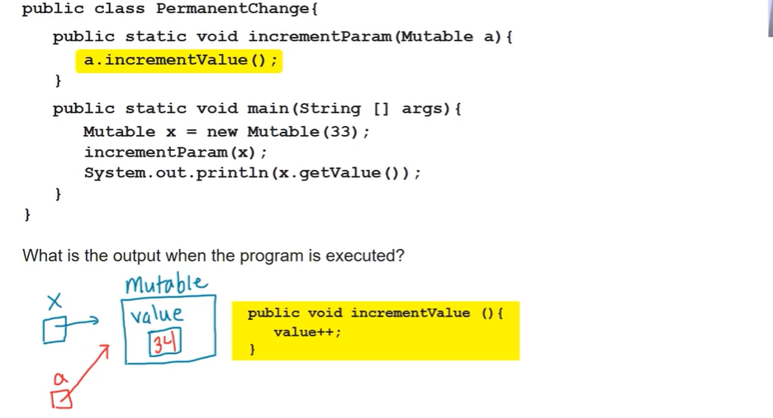

When a reference data type is passed to a method it is passed by reference. a becomes an alias for x and they both point to the same object. So value of a also changes the value of x.

Even though String is reference it is immutable so modifications inside the method do not affect the original variable.

**6.1 Array**

* Array is a collection or list of primitive or object reference data.
* Element is a single value in the array.
* Index of element is position of element in array. It starts from 0.
* Length of array is number of elements in the array. It is a public final data class in an array ie it can be accessed from any class and length of an array cannot be changed after it has been created. Can be found by list1.length. No parenthesis
* It is a reference data type
* Array are homogenous. If defines as int [] list1; it can only contain int elements otherwise it will throw error.
* Negative indexing not in Java

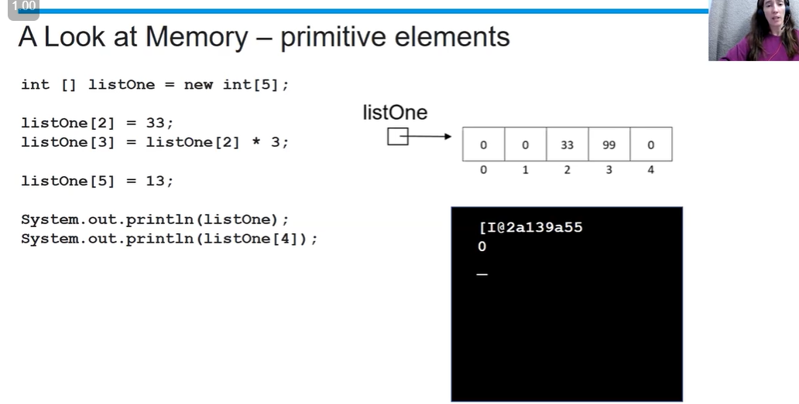



Here if we do listOne[3]=20; 5th element will now become 20.

ArrayIndexOutOfBoundException error is thrown.

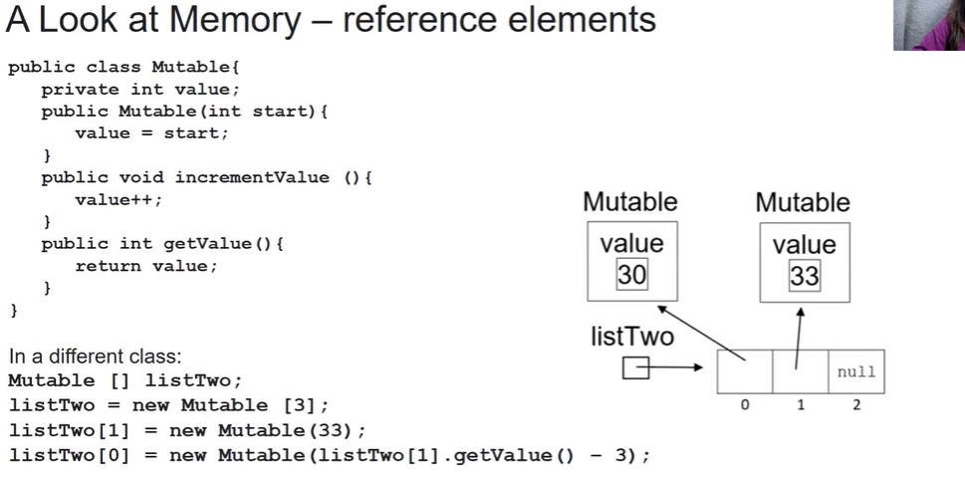



Just defines the array. Memory location doesn’t point to anything.



Elements of a reference type are initialized to reference value of null. Object of each element is not automatically created

To create object we set a particular place in the array to a new mutable object giving it a value for the constructor.

Element of type double will get initialized to 0.0. If int value given it will convert 9 to 9.0

Element of type Boolean are initialized to false.

Array can also be defined as double [] grades = {7, 8.6, 9.0}

**Traversing:** Traversing is accessing each element of array. Can be done by for and while loop with array[i]. Remember condition should be i<array.length and i should be = 0.

**6.3 Enhanced for loop**

* Also called for-each loop.
* You do not have access to the indices of the array
* Assigning a new value to the for each loop variable does not change the array

int [] values = {1,2,3,4,5}

for (int numbers : values){

sout(numbers)

}

For each iteration of this loop the for each loop variable (numbers) is given a copy of an element of the array. Here the variable number gets the values of the elements of the list. Will print 1, 2, 3, 4 and 5.

**6.4** Array std algorithms in std_alg

**7.1** **ArrayList**

* Unlike arrays which are static in size (its size can’t be changed after initializing), ArrayList are dynamic in size, the size of the list can be changed at any time.

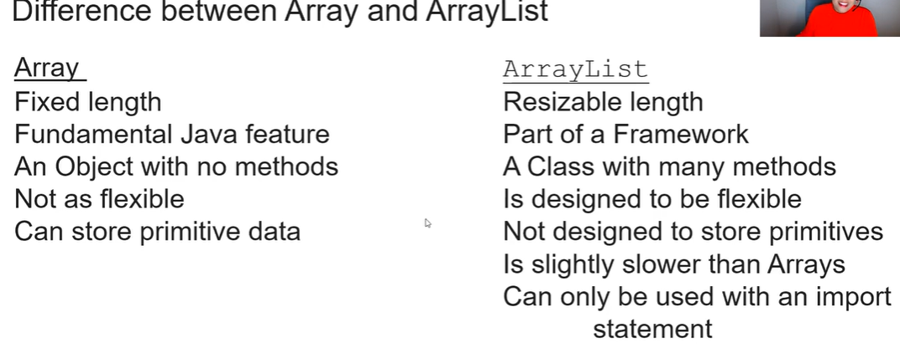

* import java.util.ArrayList or java.util.List. Best to import ArrayList. Import statement should be in the beginning before the class declaration.
* Arraylist are homogenous. Only objects which are of the same datatype with which the ArrayList was instantiated can be added.
* Refernce datatype.

ArrayList <datatype> varName = new ArrayList <Datatype>(n);

ArrayList <Integer> al=new ArrayList <Integer>();

Datatype can be any non-primitive datatype. ‘n’ is initial number of elements. It is optional no need to specify it. We can just put ().

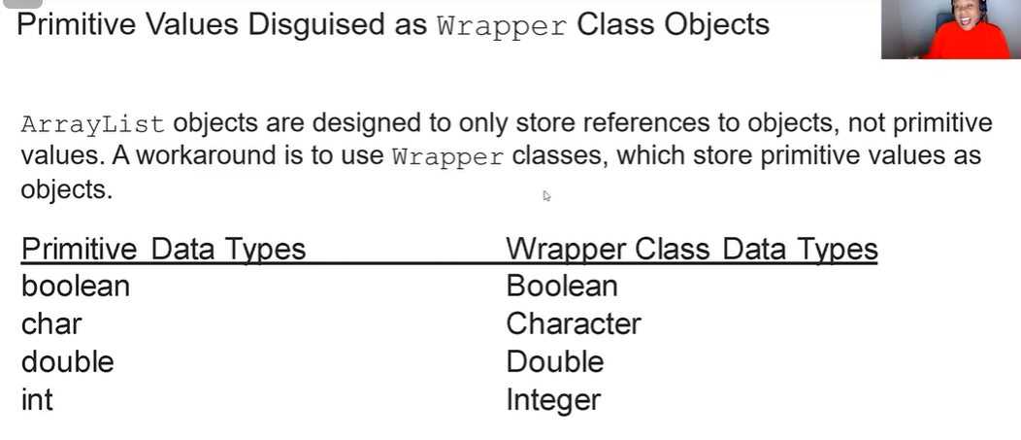

#Remember to use the capital letter wrapper data types.

#ConcurrentModificationException is thrown when we add/remove element while iterating ONLY with enhanced for loop. With normal for loop no error and we can use add and remove.

**7.2 ArrayList Methods**

**al.size()**: Gives how many elements are in this arraylist. Even if while instantiating I mention new ArrayList<Integer>(4); IT will still give me 0 since (4) does not create 4 elements it just preallocates space for 4 elements.

**al.add(index, obj):** Adds element at the specified index and moves elements at position index or higher to the right (adding 1 to the indices).

**al.add(obj):** Adds element to the end of the ArrayList.

**al.remove(index):** Removes element from index. Elements are shifted to the left (index-1). Returns the removed element.

**al.set(index, obj):** Replaces the element at index with obj. Returns the element formerly at index.

**al.get(index):** Returns element at index.

**ArrayList as Parameter in a method**

Since it is reference datatype, same behaviour as reference datatype during method calls (See above).

ArrayList<Boolean> al = new ArrayList<Boolean>();

al.add(true);

al.add(false);

void Method1(ArrayList arr){

String str1 = “Hello”;

arr.set(0, str1); //we can’t write “Hello” directly since we need an object type here

}

No error since while passing argument we did not mention datatype of ArrayList.

void method1(ArrayList <Boolean> arr){

arr.set(0,str1);

}

Now we get error.

Even when a method which returns an ArrayList best to mention datatype.

Basically for both passing and returning ArrayList better to mention ArrayList<> than ArrayList since it will help compiler to find errors that would otherwise be found at run-time.

**7.3 Traversing an ArrayList**

Same as traversing an array with for, while and enhanced for loop. Just remember we can’t do al[i] we need to do al.get(i).

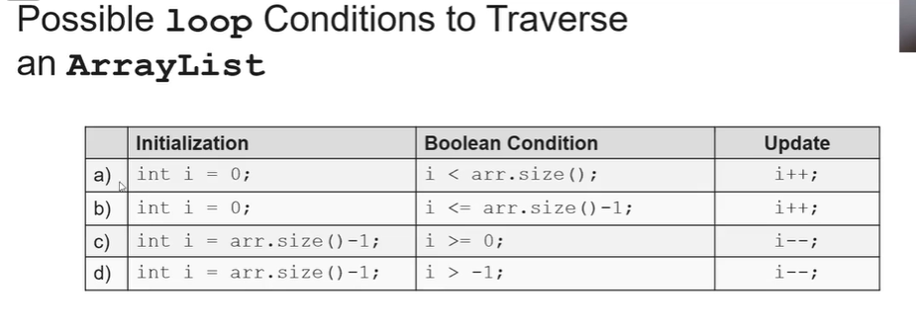

**Deleting elements during traversals**

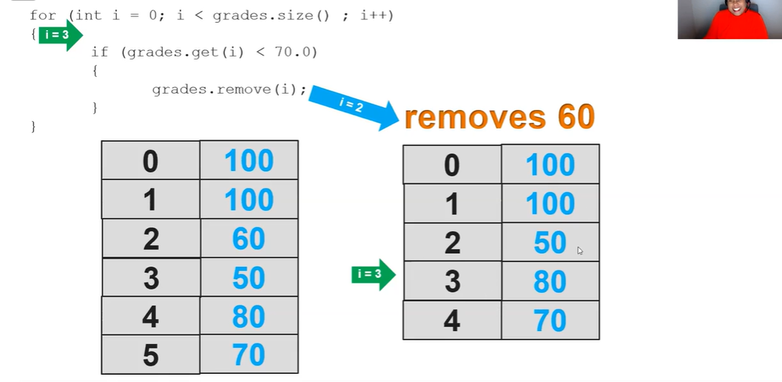

This way elements are skipped.

Solution

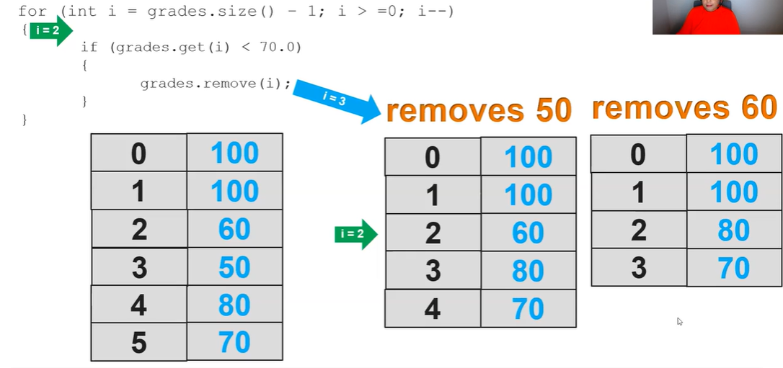

If we have to have a forward loop then inside the if block after removing the element we could do i-- so that it doesn’t skip.

Enhanced for loop works exactly the same for array and arraylist

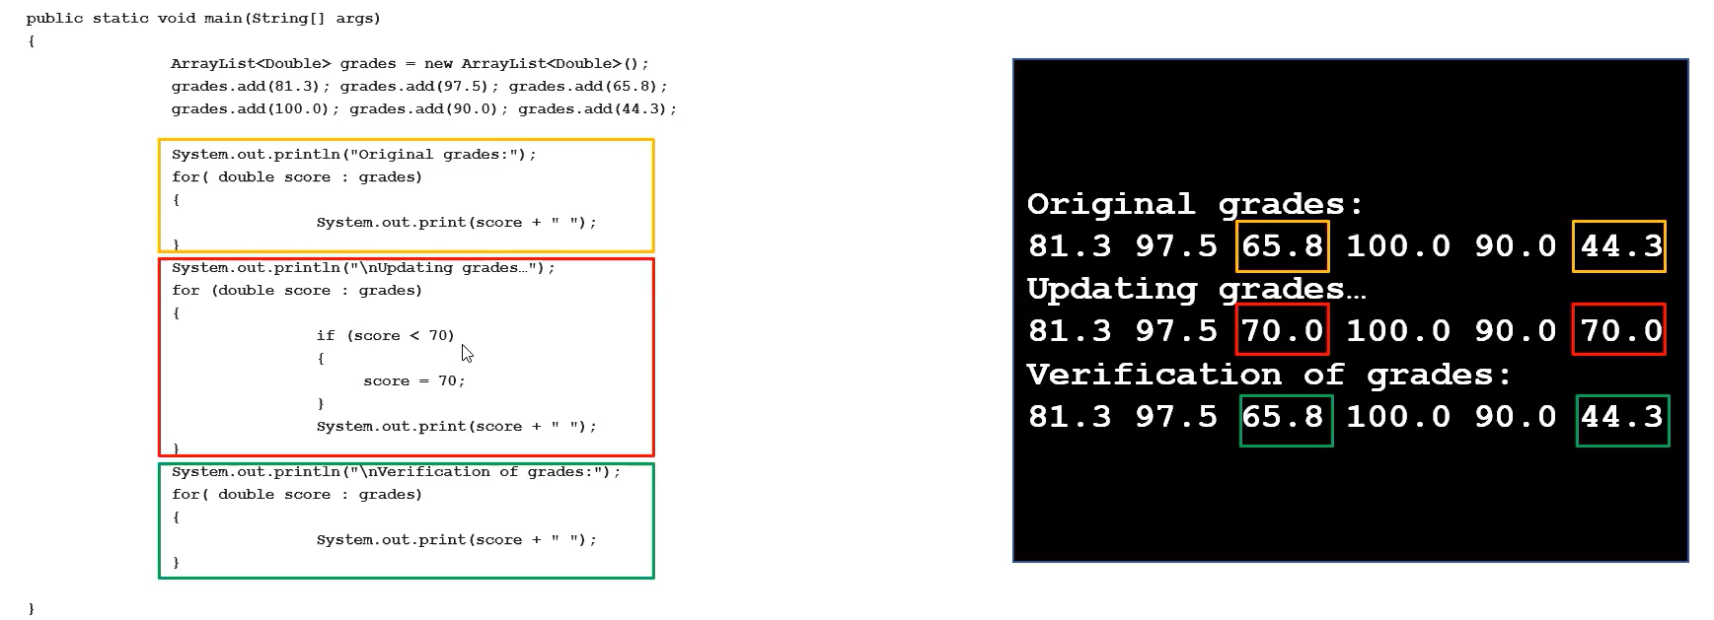

Here, the arrayList does not get updated because in an enhanced for loop the variable score is only a copy of the element and changing it does not change the original arrayList/array.

If we add or remove an element from an arraylist in enhanced for loop it will throw exception.

Therefore, enhanced for loop cant be used when we are adding, modifying or deleting elements.

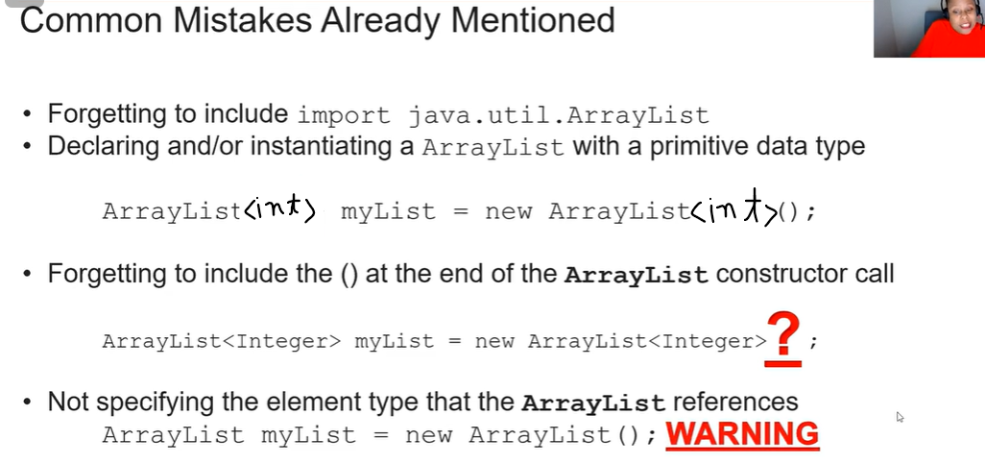

In the last point we may not get error and it will still compile the code but it may give warning and cause some issues.

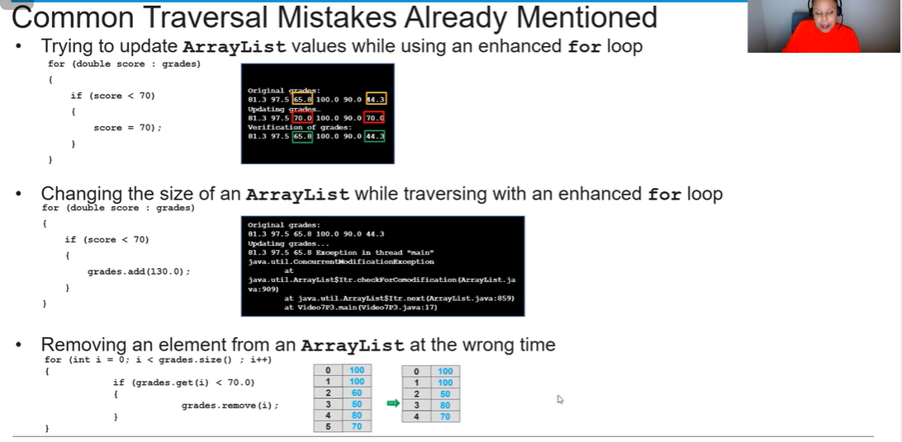

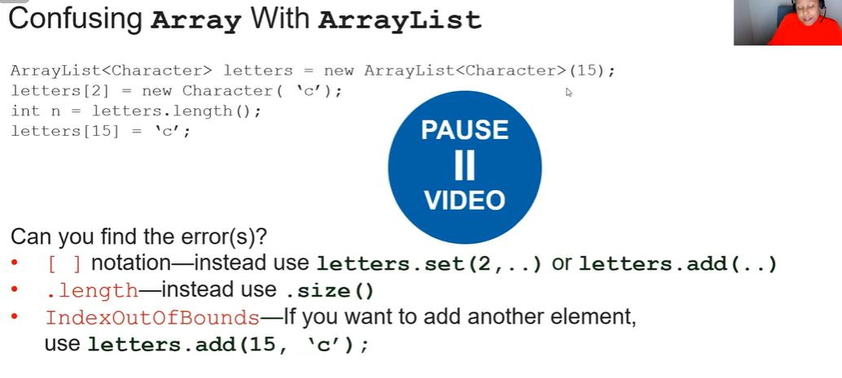

**7.6 Sorting**

See sorting project.

1. Selection sorting:

Selection Sort is a simple sorting algorithm that repeatedly finds the smallest element from an unsorted section of the array and moves it to the sorted section.

* Divide the array into two sections:
  + The sorted section (at the beginning).
  + The unsorted section (remaining elements).
* Find the smallest element in the unsorted section.
* Swap it with the first element of the unsorted section.
* Expand the sorted section by moving the boundary one step forward.
* Repeat until the entire array is sorted.

Sorting [5, 3, 8, 1, 2]

| **Pass** | **Array Before** | **Smallest Element** | **Swap Index** | **Array After** |
| --- | --- | --- | --- | --- |
| 1 | [5, 3, 8, 1, 2] | 1 | Swap 5 & 1 | [1, 3, 8, 5, 2] |
| 2 | [1, 3, 8, 5, 2] | 2 | Swap 3 & 2 | [1, 2, 8, 5, 3] |
| 3 | [1, 2, 8, 5, 3] | 3 | Swap 8 & 3 | [1, 2, 3, 5, 8] |
| 4 | [1, 2, 3, 5, 8] | 5 | Already sorted | [1, 2, 3, 5, 8] |

1. Insertion sort

Insertion Sort is a simple, efficient sorting algorithm that builds a sorted array one item at a time.

* Divide the array into two sections:
  + A sorted section (initially just the first element).
  + An unsorted section (remaining elements).
* Pick the first element from the unsorted section and compare it with the sorted elements.
* Shift elements in the sorted section to make space for inserting the current element at its correct position.
* Repeat until the entire array is sorted.

Example: Sorting [5, 3, 8, 1, 2]

| Pass | Array Before | Picked Element | Sorted Section | Final Position | Array After |
| --- | --- | --- | --- | --- | --- |
| 1 | [5, 3, 8, 1, 2] | 3 | [5] | Before 5 | [3, 5, 8, 1, 2] |
| 2 | [3, 5, 8, 1, 2] | 8 | [3, 5] | Stays | [3, 5, 8, 1, 2] |
| 3 | [3, 5, 8, 1, 2] | 1 | [3, 5, 8] | Before 3 | [1, 3, 5, 8, 2] |
| 4 | [1, 3, 5, 8, 2] | 2 | [1, 3, 5, 8] | Before 3 | [1, 2, 3, 5, 8] |

Insertion sort is better than selection sort because the structure is sorted to the current value of execution.

**Execution count of sorting:** When discussing sorting algorithms in AP CSA, we often compare them based on their execution time. However, instead of using exact numbers, we estimate their efficiency using a concept called Big-O notation.

Big-O notation helps classify algorithms based on how their runtime grows as the number of elements (n) increases.

For insertion and selection sort, O(n2). The notation O(n²) means that as the number of elements (n) increases, the number of operations grows proportionally to n².

In these algorithms:

- We use two nested loops to go through the array and compare elements.

- The inner loop runs approximately n times for each iteration of the outer loop, resulting in n × n = n² total operations.

**7.7 Ethical issues around data collection**

We should not collect more data than needed. When we no longer need data we should explicitly remove it. Lets say we take in user’s firstName. Then when it is not needed we should firstName=null.

We should not use personal info as identifier. Lets say we take in fullName. Then we do identifier = fullName.hashcode() and fullname=null. This is called anonymizing personal data.

**8.1 2D Array**

2D arrays are arrays which holds elements which are also arrays.

Rectangular 2D array: Each row array has same number of elements. (Non-rectangular 2D array not in scope of this exam)

Declaring: int[][] varName= new int[r][c];

* r is the number of rows or number of arrays
* c is the number of columns or number of element/length of each array.

OR = {{1,2,3},{4,5,6},{7,8,9}}

Size: We refer to its size by r by c.

r = varName.length

c=varName[0].length

Accessing/updating elements: varName[r][c]=29;

Traversing

for (int row=0; row<a.length; row++){

for (int col = 0; col < a[0].length; col++) {

System.out.print(a[row][col]);

}

System.out.println();

}

Enhanced for loop

for (int[] x:a){

for(int y:x){

System.out.print(y);

}

System.out.println();

}

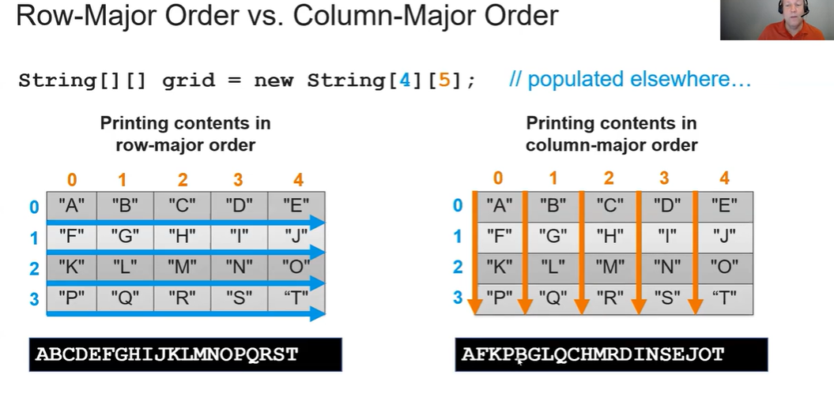

For column-major traversing just make outer loop for column and inner loop for row.

for (int col = 0; col < a[0].length; col++) {  
 for (int row = 0; row < a.length; row++) {  
 System.out.print(a[row][col]);  
 }  
 System.out.println();  
}

#Can’t use enhanced for loop for column major traversing.

**9.1 Inheritance**

* Parent classes (or Superclasses) have attributes and behaviours that can be inherited by child classes (or subclasses).
* Used to build hierarchy of classes that have similar characteristics.
* Each subclass can only have one superclass.
* All subclasses inherent all attributes and behaviours of Superclasses.
* Inheritance of methods and variables can be done many generations down. Balletdancer object can call practice method. (See SS below)

Why use it?

* Code reusability: Higher level classes can be used over and over again in many situations
* Prevents repeating code: Common methods and variables are now in one location.
* Organisation and Readability
* Ease of maintenance: Changing common behaviour and attributes

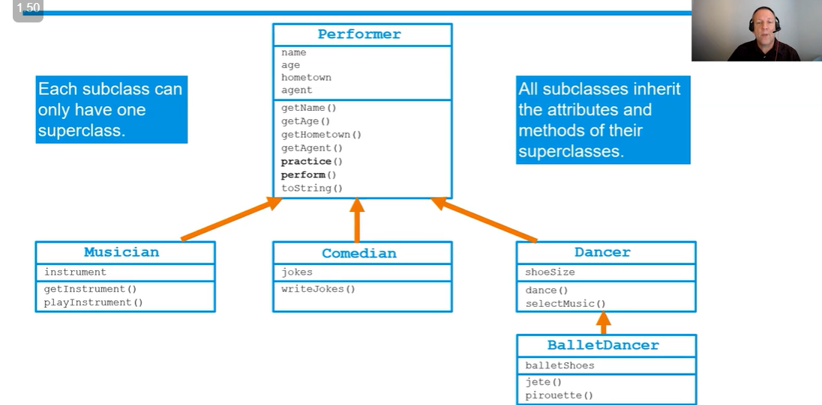

#Balletdancer is still considered a subclass of performer.

Extend keyword

To declare a class as subclass of a superclass we use extend keyword.

public class Musician extends Performer {}

The musician class inherits all the public methods and instance variables but not the private ones.

So, we can do MusicianObj.perform(); but we can’t do performerObj.playInstrument();

If in a method Performer obj is a parameter. Due to inheritance we can give any subclass of Performer as the parameter.

Constructors

Constructors are not inherited by subclass.

If performer has constructor instantiating name and age. While creating a Musician object we can’t use the signature of performer constructor.

# When a subclass constructor is called, the parameterless constructor of parent class is automatically called. Performer has parameterless constructor with name = “Unknown”. MusicianObj1 is created. If we sout MuscianObj1.name. It will give Unknown.

Super keyword

Above we saw how by default, no-parameter constructor is called. To call a parameterized constructor we use the super() keyword.

It has to be called in the first line of the constructor.

Let’s say Performer has a constructor initializing name and age. Musician has a constructor with three parameters name, age and instrument. Now we cant do name = n because in AP all variables need to be private and subclasses have no direct access to private instance variable of superclass. So we need to use super(n,a) which will call the name and age constructor. So now the MusicianObj has name, age and instrument.

#To create a subclass object we do not need to create the superclass object still the child class would get all variables and methods and super and everything will work.

Super Keyword (Second use)

This use case of super keyword can only be used within a method of a subclass. It lets you access superclasses’s methods and even variables which we normally can’t since they are private. (But remember we can do super.name but can’t do performer.name since name is non-static and belongs to object not class)

Let’s say BalletDancer, Dancer and Performer all have a method perform() (Say A,B,C for ease). When BalletDancer obj calls perform() it calls A.

If I want A method to contain B. If I just write perform() java will take it as A. But if I write super.perform() Java will take it as B.

If I also want to call C I cant do that in A. I would have to do that in B with super.perform(). So when A is called it calls B which in turn calls C.

#In constructor super always had to be in the first place. Here we can call super.perform() anywhere in A.

**9.3 Overriding methods**

Let’s say in Comedian I write another method perform() with the same signature as in Performer. When I call comedianObj.perform() it will call the perform method I defined in comedian not in performer class.

**9.5 Creating References Using Inheritance Hierarchies**

Objects of subclasses can be referenced using superclass types.

Performer p1 = new Musician();

If we do p1.perform(); It will do Musician perform method since the actual object is Musician even though datatype is Performer.

#We can’t do Musician m1 = new Performer(); Object (on the right) has to be subclass and the reference (on the left) has to be superclass.

#We can even do Performer p1 = new BalletDancer(); Since ballet dancer is child of dancer which is child of performer.

Usage: This is used to while declaring collections such as Array and ArrayLists. They have to be of a certain datatype but may need to contain different types. If we need an Array of performers

Performer[] performers = {new Musician(), new Dancer(), new Singer()};

If we iterate thru performers and call perform() of each element then it will execute the perform method of the Musician/Dancer/Singer object.

**9.6 Polymorphism**

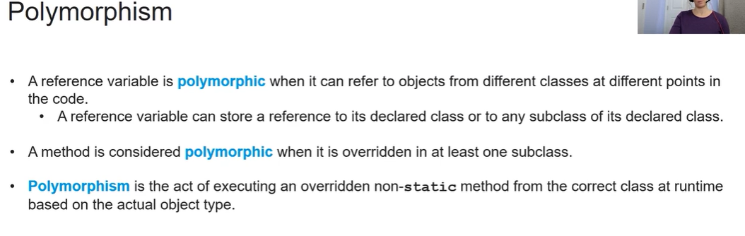

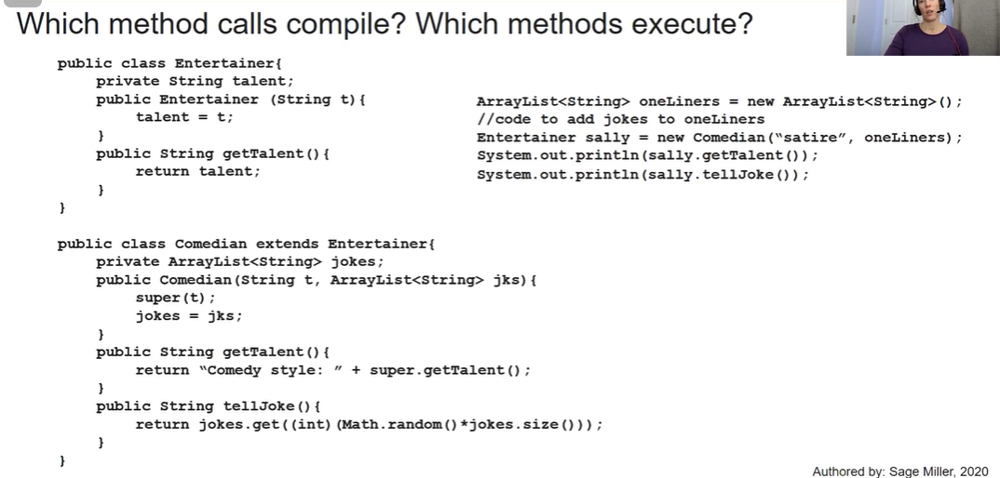

Sally is of datatype Entertainer but references a Comedian object.

When we do sally.getTalent(), the compiler checks in Entertainer class and finds the method. But at runtime, since Sally is a comedian it executes getTalent from comedian class.

When we do salley.tellJoke(), the entertainer doesn’t have a tellJoke() method so it doesn’t compile.

To make it work we use *downcasting.*

sout(((Comedian)sally).tellJoke()); Since sally references a comedian we can ask it to be downcast to a comedian. So compiler sees it as a comedian object and checks in the comedian class to see if there is a tellJoke() method.

# If two classes brid and subclass pigeon both with act and eat method. pigeon.act() has super.act and. Bird.act has eat(). When we do pigeon.act() it calls super.act then eat() of the pigeon class.

**9.7 Object Class**

* Object class is superclass of all other classes in Java.
* Object class is part of java.lang which is imported by itself. No need to import it.

**obj.toString()**

* Each object inherits the toString() method from Object Superclass.
* When an object is passed as an parameter to the print() and println() statements, the toString() method is automatically called.
* It returns name of object@ hashCode() value of object which isn’t very useful
* We can override this method by writing what we want to display when the obj is printed in public String toString(){}
* If a class writingutensil has an overriding toString() method and pen is its subclass. If we print penObj then it will inherit the toString() from writingutensil.

**obj1.eqauls(obj2)**

* Returns true or false
* Every object inherits this from Object superclass
* The equals() method inherited from Object returns whether the objects ‘==’ i.e. if the two variables refer to the same object or not. Which is not what we may want
* To solve this, we can write an overriding method.

public Boolean equals (Object obj) {

WritingUtensil that = (WritingUtensil) obj;

return this.tipsize == that.tipsize;

}

* A subclass of writingutensil will take the overriding equals() method instead of the Object class one.

**10.1 Recursion**

A recursive method is a method which calls itself.

A recursive can be written as iterative and vice-versa.

If parameter is mutable data structure the recursive statement can alter it.

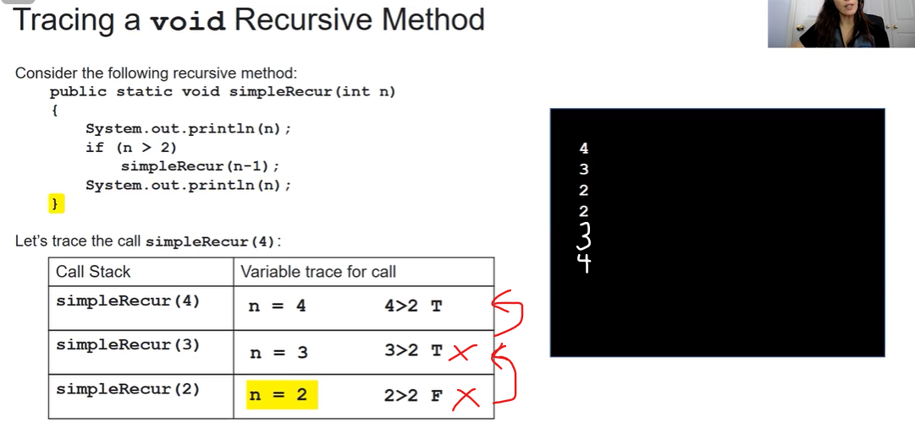

First 4 is printed. 4>2 so simpleRecur(3) is called, a new variable n=3 is formed and 3 is printed. 3>2 so simpleRecur(2) is called and 2 is printed. 2 is not greater than 2 so condition is not fulfilled. This is known as base case since the recursive call is skipped. 2 is printed again. Then simpleRecur(2) is completed and simpleRecur(3) is continued, 3 is printed and it is completed and simpleRecur(4) is continued, 4 is printed and code is completed.

**Base case** is the condition that terminates the recursive calls. (n<=2 is the base case here)

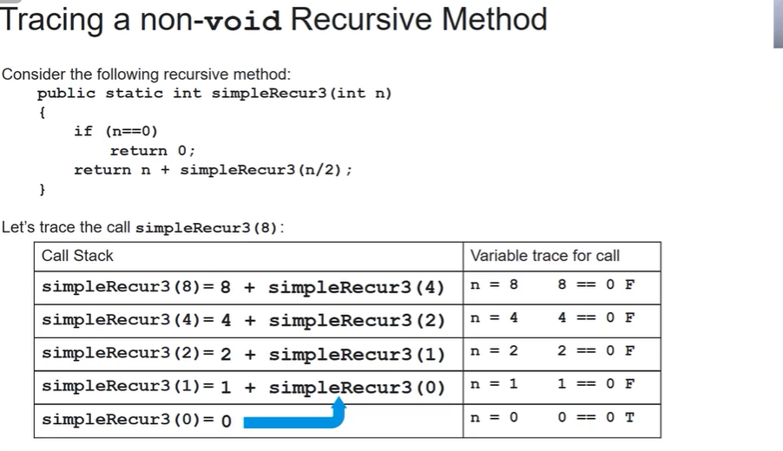

so it will return 8+4+2+1+0.

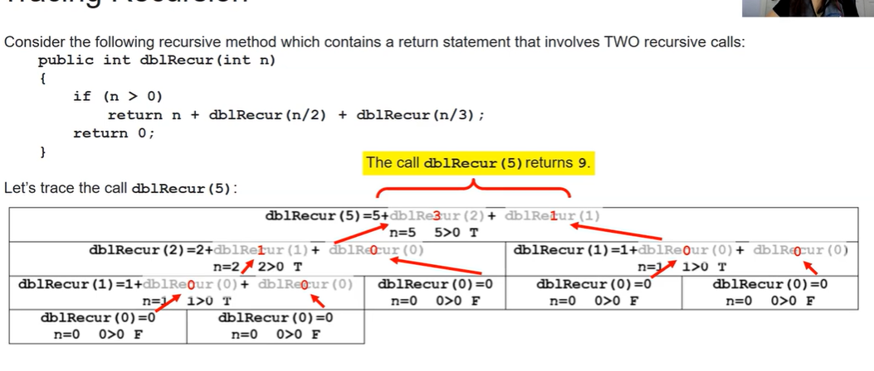

**Binary Search**

1. **Start with a sorted array** (Binary Search **only works on sorted data**).
2. **Find the middle element**.
   * If the middle element is the target, **stop**.
   * Otherwise, decide whether to search **left** or **right**:
     + If the target is smaller, search the **left half**.
     + If the target is larger, search the **right half**.
3. **Repeat the process** until the element is found or the array size reduces to zero.

For code see Sorting.

**Merge Sort**

Merge Sort is an efficient, divide and conquer sorting algorithm. It works by splitting the array into smaller sub-arrays, sorting them individually, and merging them back together in sorted order.

How Merge Sort Works

1️. Divide: Split the array into two halves recursively until each half contains only one element.  
2️. Conquer: Sort each half individually using recursion.  
3️. Merge: Combine the sorted halves to form a single sorted array.

Example: Sorting [5, 3, 8, 1, 2]

| Step | Array Split | Sorted Merge |
| --- | --- | --- |
| 1 | [5, 3, 8, 1, 2] → Split into [5, 3] and [8, 1, 2] | - |
| 2 | [5, 3] → Split into [5] and [3] | [3, 5] |
| 3 | [8, 1, 2] → Split into [8] and [1, 2] | [1, 2, 8] |
| 4 | Merge [3, 5] and [1, 2, 8] | ✅ Final Sorted Array: [1, 2, 3, 5, 8] |

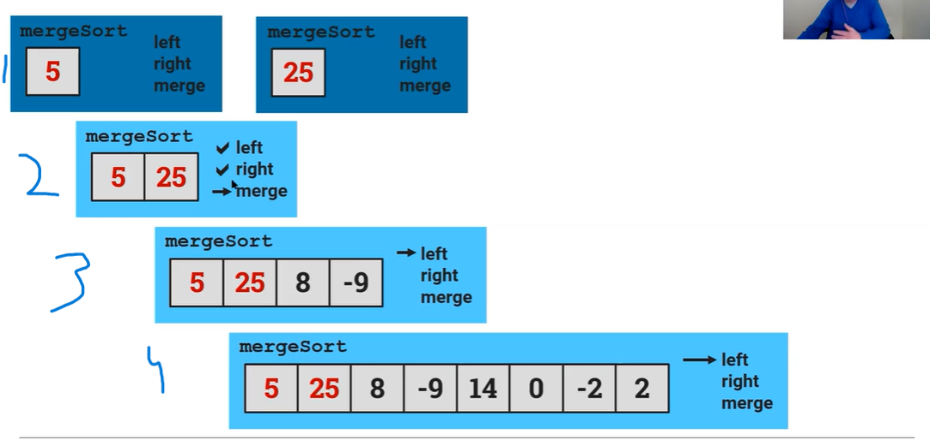

It first divides into left part which keeps on dividing into left parts until only one element is left. Then it divides the 2 right part which will also only have one element and then they will merge. It will go down to 3 and divide right part until only one element and then merge.

Basically each recursion involves left, right and then merge.

Basically mergeSort(fullArray){

mergeSort(left part of array)

mergeSort(right part of array)

merge(left and right)

}

Merging Part

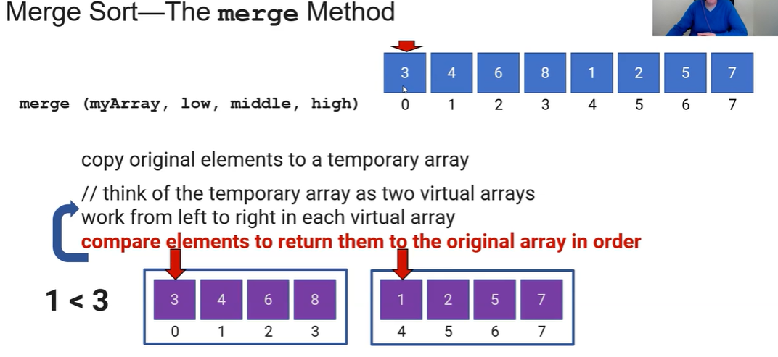

Here we will have 3 variables li which would be the first index of the left part of the array, ri: first index of the right part of the array and i will be the first index of the main array that needs to sorted. It will then compare element at li and ri which ever element is smaller lets say ri is smaller so the element of would take the place of i in the main array and i would increment by one and ri would increment by one li would remain the same. Next again the elements will again be compared, smaller one lets say the li would be added at index i in the main array, i and li would increment by one but this time ri would remain same.

#Note: Actual merge sort code will not come in AP CSA only understand the logic and code.

**Errors:**

1. ArrayIndexOutOfBoundsException
2. ArithmaticException: dividing by 0.
   1. #If division by zero occurs in the first part of a compound test, an ArithmeticException will always be thrown. If the division is in the second part of the test, you won’t get the exception if the value of the whole test is already known (short-circuit evaluation).
3. NullPointerException: Calling a method or accessing a field on a null object.

#Using object in another object is termed as composition.

# Merge sort and binary search follow divide and conquer not insertion sort.

#Break and continue are part of Java.